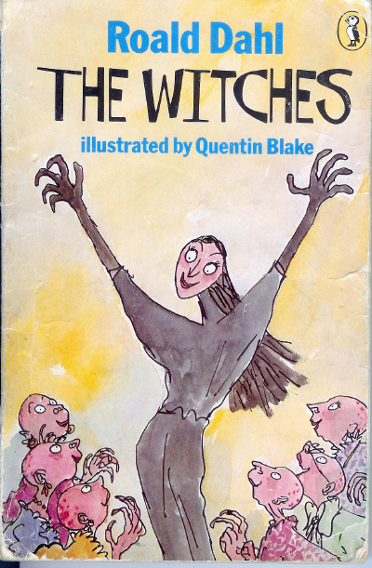

Name:

The witches

The Witches certainly are an evil bunch of creatures! Take your mind off them by trying to put these words into alphabetical order.
witch ________________
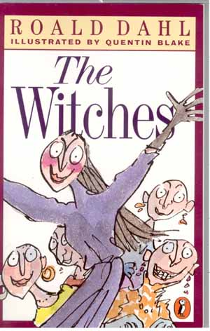
mouse ________________
grand ________________
whiskers ________________
Norway ________________
bald ________________
nostrils ________________
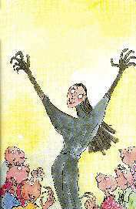
fritter ________________
evil ________________
Bruno ________________
horrible ________________
spell ________________
Grandmama ________________
kitchen ________________
gloves ________________

______________________THE WITCHES
You are lucky enough to know how to spot a witch. Using BULLET POINTS list all the things that tell you if a woman is a witch or not.
________________________________________________________________________________________________________________________________________________________________________________________________________________________________________________________________________________________
Now draw two pictures below. One of a normal ordinary woman, and one of a witch.

______________________THE WITCHES
You have read all about the five children who disappeared when Grandma was a girl. Briefly explain how each of them disappeared.
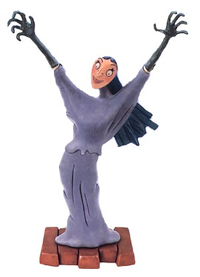
Ranghild Hansen ______________________
______________________________________________________________________
Solveg Christiansen ___________________
______________________________________________________________________
Birgit Svenson _______________________
______________________________________________________________________
Harald _____________________________
______________________________________________________________________
Leif _______________________________
______________________________________________________________________

______________________THE WITCHES
Now draw a colour picture of what each child looked like (turned into) after they had an encounter with a witch.
Solveg Christiansen Birgit Svenson

Harald Leif

Can you write a sentence explaining why there was no picture box for Ranghild Hansen? __________________________________________________________
________________________________________________________________

______________________THE WITCHES
In the chapter “The Grand High Witch” the young boy is building a tree- house when a strange woman starts talking to him.
What does she try to get the young boy to do?
________________________________________________________________________________________________________________________________________________________
Using bullet points list the things you should do if you are ever approached by a stranger?
________________________________________________________________________________________________________________________________________________________________________________________________________________________________________________________________________________________________________________________________

The Grand High Witch
On this page you need to write a detailed character portrait about the Grand High Witch. You should include information which explains; who she is, what she looks like, how she behaves and what are her goals and plans.

___________________________________________________________________________________________________________________________________________________________________________________________________________________________________________________________________________________________________________________________________________________________________________________________________________________________________________________________________________________________________________________________________________________________________________________________________________________________________________________________________________________________________________________________________________________________________________________________________________________________________________________________________________________________________________________________________________________________________________________________________________________________________________________________________________

__________________________THE WITCHES
Roald Dahl uses “speech marks” to show when characters in the book are actually talking. Have a look at the speech bubbles below and add the appropriate “Speech Marks” as well as Question (?) or Exclamation (!) marks.
What colour eggs
Are you a witchofile Grandma

It was a mask

She was wearing a wig

What an adorable dress you have on
We can’t possibly wipe out all of them

Children are dirty and stinky
Vot am I seeing

MISSING PERSON
Name: Bruno Jenkins
Age: ___________
Height: ___________
Weight: ___________
Hair: ___________
Eyes: ___________
Last seen: _____________________________
______________________________________
Wearing: ______________________________
____________________________________________________________________________
Distinguishing Marks/Habits:_____________
____________________________________________________________________________


If you have any information regarding the whereabouts of this missing person please contact the Bournemouth Police Department immediately on 8855 895 6215 or via our new interactive website www.bournemouth-police-missing.co.uk

______________________THE WITCHES
Read the relevant chapters and answer the questions in sentences.
My Grandmother
- List what happened to at least two children in Grandma’s story?
__________________________________________________________________________
- Do you think this is really possible? Explain your reasons.
__________________________________________________________________________
Frizzled Like a Fritter
- What did one foolish witch dare to say the Grand High Witch?
____________________________________
- What did the Grand High Witch do?
____________________________________
Formula 86 Delayed Action Mouse Maker
- What does this magic potion do?
__________________________________________________________________________
Bruno Jenkins Disappears
- What did the Grand High Witch promise Bruno?
____________________________________
- What happens to Bruno at the end of the chapter?
__________________________________________________________________________
_________________________________________________________________________________________________________________________________________________________________________________________________________________________________________________________________________________________________________________________________________________________________________________________________________________________________________________________________________________________________________________________________________________________________________________________________________________________________________________________________________________________________________________________________________________________________________________________________________________________________________________________________
Reviewed by: ____________________ Star Rating: ⬄⬄⬄⬄⬄

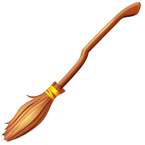
A BEWITCHING REVIEW
You have been asked to write a book review for ‘Which Witch Magazine’
Your review should not simply be a retelling of the story. You should of course include what the story is about, but this should not make up the bulk of your review. You need to talk about your experience with the book.
- Who were the author and illustrator?
- Why did you choose that book?
- What did you like about the book (humour, action/action, suspense)?
- What rating out of 5 stars would you give this book and would you recommend it to someone else?
_________________________________________________________________________________________________________________________________________________________________________________________________________________________________________________________________________________________________________________________________________________________________________________________________________________________________________________________________________________________________________________________________________________________________________________________________________________________________________________________________________________________________________________________________________________________________________________________________________________________________________________________________
Reviewed by: ____________________ Star Rating: ⬄⬄⬄⬄⬄

