How many words can you make using “ing”?
smiling having knot ting noting writing
nothing taking making
shaking baking
- b a __ __ n __
- n __ t __ __ g
- n __ t __ __ __ __
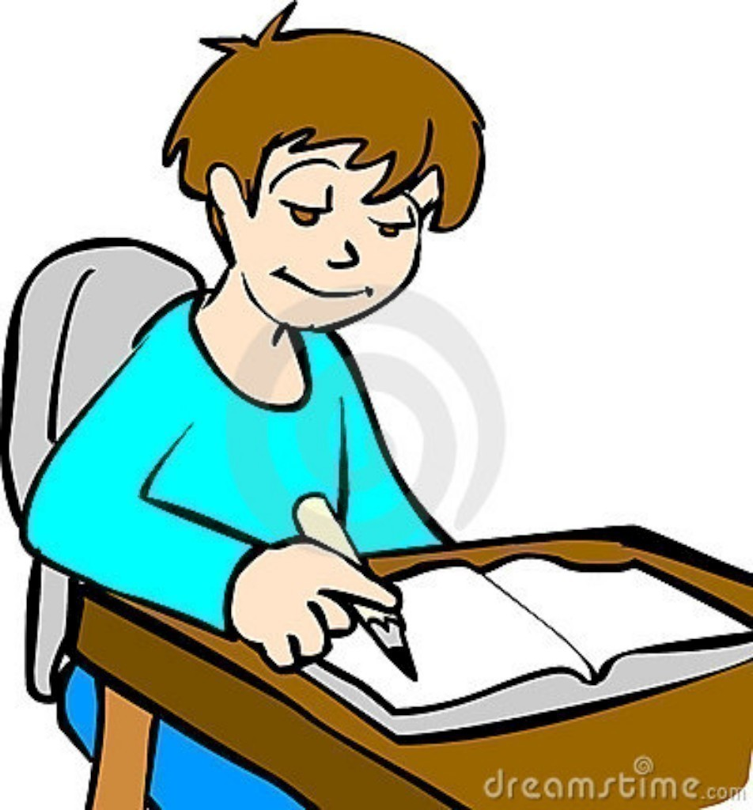
- s m __ l __ __ __
- m __ __ i __ __
- k __ o __ __ i __ g
- s __ a __ __ __ __
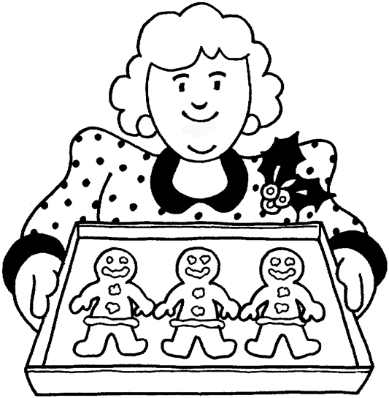
- __ r __ t __ n __
- h __ __ __ n __
- __ a __ __ n g

Add the ‘ing’. (Remember to take off the ‘e’).
Take off the ‘e’, add ‘i..n..g’!

- have = ______________ 7. take = ______________

- whine = ______________ 8. choke = _____________


- flake = ______________ 9. wave = ______________

- wake = _______________ 10.save = ______________

- poke = _______________ 11. make = _____________

- brake = ______________ 12. Live = ______________
Add the ‘ing’. (Remember to double the consonant first). Double the letter to add ‘ing’!

- drop = _____________ 15. sit = ____________

- bat = ______________ 16. get = ____________

- pop = ______________ 17. mop = ___________

- shop = _____________ 18. wet = ___________

- cut = ______________ 19. let = ____________

- shop = _____________ 20. sag = ___________

- drag = ________________

- hum = _________________

- occur = ________________
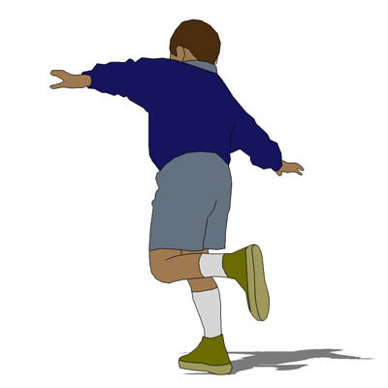
- hop = _________________

- step = _________________

- clap = _________________


- trim = _________________

- plod = _________________

