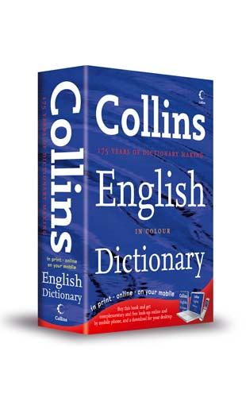
Change these nouns into adjectives by adding the suffix “-y”
You will need to use a dictionary to check the spellings.
sun

sunny
fun

fun_ _
stone
run
cloud

stone _

run _ _

cloud _
Now try these…
Don’t forget to use a dictionary to check the spellings.
cheese

cheese _
curve

curve _
ice
bag

ice _

bag _ _
Now try to write a sentence for each adjective.
Remember to edit with V C O P!

