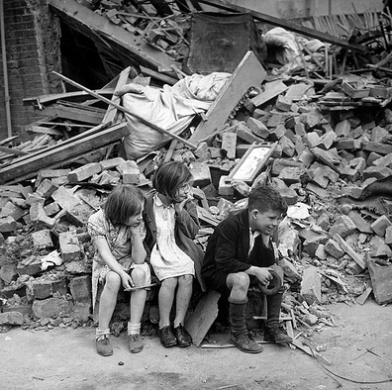
‘Air raid’ by Jean May

Read pages 3-9 and answer the following questions:
- Through whose eyes is the story being told?
- Turn to page 9 and find the final paragraph (but don’t carry on reading after this!). What do you think the boys saw that made them ‘gasp with horror’? Draw a picture to show your answer.

Read pages 10- 18 and answer the following questions:
- What has happened to Crown Street that made the boys ‘gasp with horror’? How do you think this happened?
- Read page 16 and imagine you are the dog at this point in the story. How to you feel when you see Harry?
- What is the dogs name and why does it have this name?
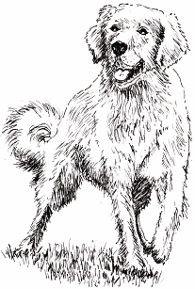
Read pages 19-25 and answer the following questions:
- Draw one of the characters, Raf, Jack or Harry, and use thought clouds to show what they are thinking while they are caught in the Air Raid.
Try to write at least three thoughts for your character.

- How many words can you find the author has used during the Air Raid (pages 19-25) to show how frightening it was?

Read pages 26-35 and answer the following questions:
- How do you think the boys are going to escape from the wine cellar? Write an ending for the story.

Read pages 36-45 and answer the following questions:
- Use one full page of your reading journal to create a danger sign/poster warning people not to go near unexploded bombs

Read pages 46-54 and answer the following questions:
- Why does Harry warn Jack to talk quietly around the bomb?
- Imagine you have been rescued and are safely at home. Write a diary entry about how you felt when you were stuck in the crater with the unexploded bomb.

Read pages 55-63 and answer the following questions:
- Write a book review for the book.

