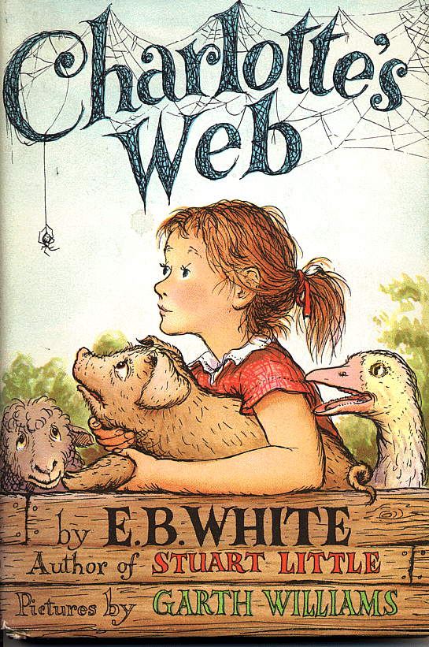
Chapter 1 – 2
Write out the sentences in the correct order.
- She tried to take the axe from him.
- Fern decided to call the pig Wilbur.
- Fern’s father gave her the runt to raise.
- Fern’s father went to the hoghouse with an axe.
- Mr Arable brought the pig into the house.
- Fern ran after him to stop him.
- Fern fed the pig some warm milk.
- He was going to kill the runt of the litter.

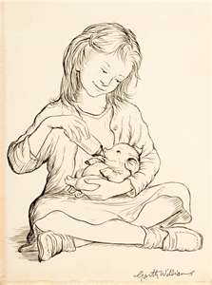

Chapter 3 – 4
Match the halves of the sentences.
- Wilbur lived
- Fern came to visit him
- One day Wilbur
- A goose told Wilbur
- He pushed a loose board
- Wilbur headed down
- Mr Zuckerman and Avery
- Wilbur didn’t like
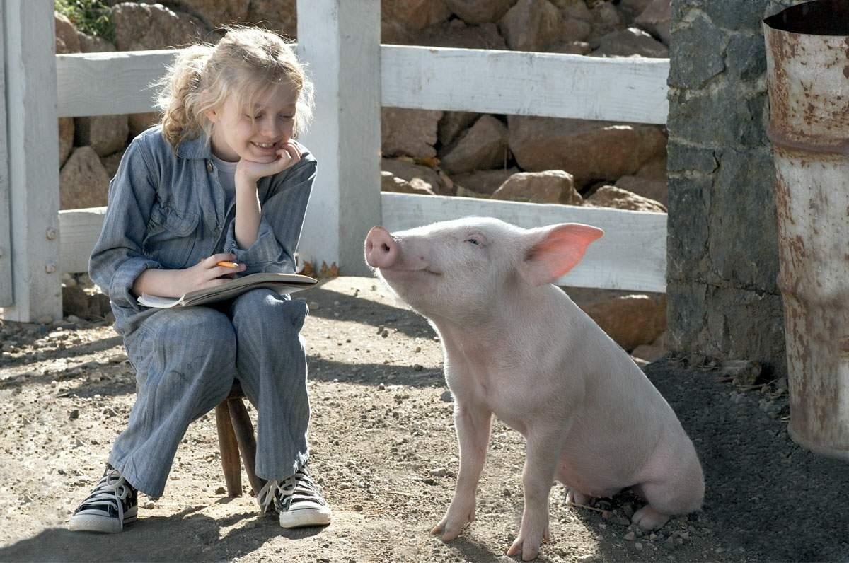
was feeling bored. in the fence. being out of his pen. every day. chased him. in Mr Zuckerman’s barn. to the orchard. how to escape.

Chapter 5 – 6
Use the novel to find the missing words.
Wilbur couldn’t __________ that night for wondering who his new __________ could be. He was just settling down for his __________ nap when he __________ a voice. His new friend was a __________ __________ spider called Charlotte. Wilbur thought she looked very __________ but thought she was very __________ because of the way she killed and ate flies.
__________ of the goose’s eggs hatched. Templeton the Rat took away the __________ one that had not __________.
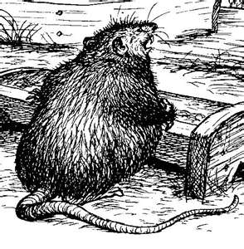

Chapter 7 – 8
Who said these things?
- “It’s a little service I throw in,” said __________.
- “You’re putting on weight,” said __________.
- “I don’t want to die,” cried __________.
- “I am going to save you,” said __________.
- “Who’s Charlotte?” asked __________.
- “Wilbur adores Charlotte,” said __________.
- “Time for Sunday School,” said __________.
- “Maybe they do talk,” said __________.
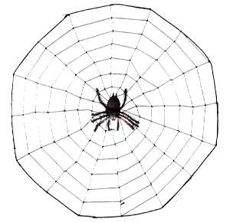

Chapter 9-10
Sort out the muddled sentences.
- a tried web. to Wilbur weave
- think way tried Wilbur. a Charlotte to to save of
- on Avery swing. and Fern rope played the
- to went two The Wilbur. children visit
- capture to Avery Charlotte. wanted
- trough. fell He Wilbur’s on
- broke. The egg rotten
- smell There terrible barn. was a the in
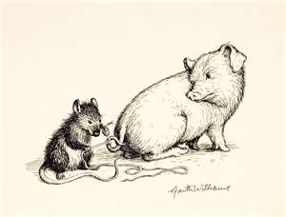

Chapter 11-12
True, false or can’t tell?
- The message said SOME PIG!
- Mr. Zuckerman’s best suit was grey.
- Mr. Zuckerman liked the Minister.
- Lots of people came to see Wilbur.
- The field was full of cars.
- Wilbur called a meeting of the animals.
- Wilbur thought he was ordinary.
- It would take Charlotte five hours to write TERRIFIC.
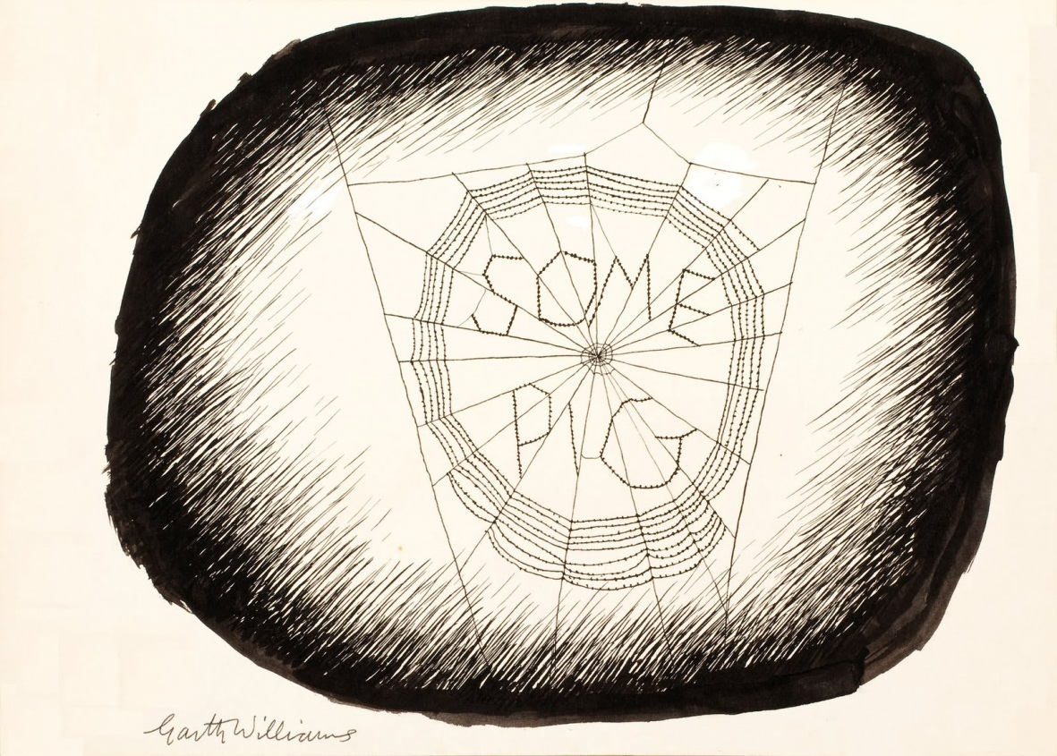

Chapter 13-14
Correct the sentences.
- Charlotte sang as she built her web.
- Mrs. Zuckerman telephoned the television reporter.
- Wilbur had clean hay to sleep on.
- Lurvy was to build him a sty.
- The Country Fair was in August.
- Charlotte’s cousin had caught a frog.
- Mr. Arable was worried about Fern.
- She went to talk to the Minister.
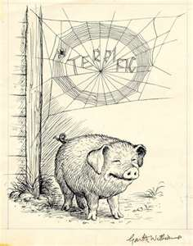

Chapter 15-16
Choose the best word.
- Crickets singing marked the end of (spring, summer, autumn).
- Mrs. Zuckerman gave Wilbur a bath in (milk, water, buttermilk).
- Wilbur was dirty behind his (neck, ears tail).
- Charlotte hid in (a knothole, the straw, the truck).
- The (sheep, goose, horse) told Wilbur to struggle.
- Wilbur realised he was still going to be (sold, bathed, killed).
- Wilbur (fainted, slept, died).
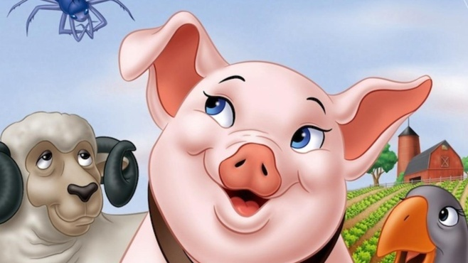
- (Lurvy, Avery, Fern) threw water on him.

Chapter 17-18
Fern Avery Wilbur Charlotte
Crept into a corner
Went on the Ferris wheel
Drank some skimmed milk
Sent Templeton to find a word
Won a balloon
Met Henry Fussy
Wanted Charlotte to sing
Wanted to steer a jet plane
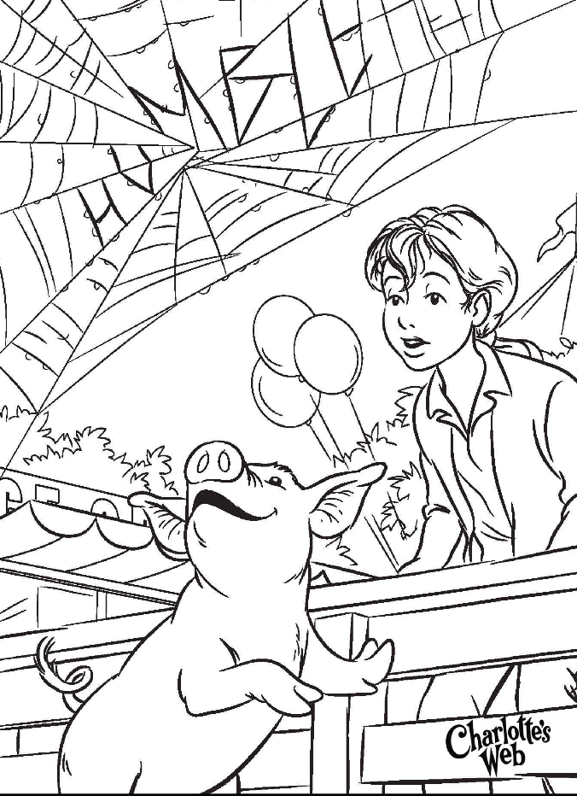
Won a monkey doll
Wanted a raspberry soda pop
Tried to look extra good
Spoke to uncle

Chapter 19-20
Answer these questions in sentences.
- What had Charlotte done during the night?
- Why did Charlotte feel sad?
- Who gave Wilbur a bath?
- Why did Fern want money?
- Why did Wilbur faint?
- What woke Wilbur up?
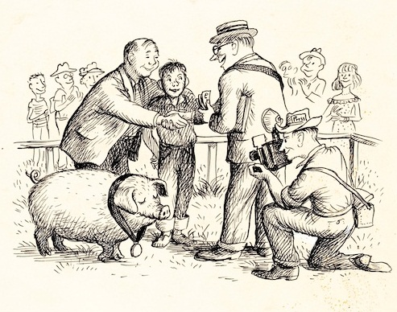

Chapter 21-22
Complete the sentences
- Charlotte was quiet because
- Wilbur screamed at Templeton because
- Templeton brought the egg sac to Wilbur because
- Wilbur had never seen snow before because
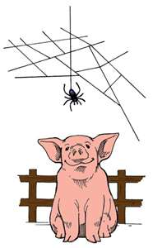
- Fern stopped coming to see Wilbur because
- Templeton grew fat because

