Name: ________________________ Date:__________________

Year 3/4 Literacy - er and est suffixes

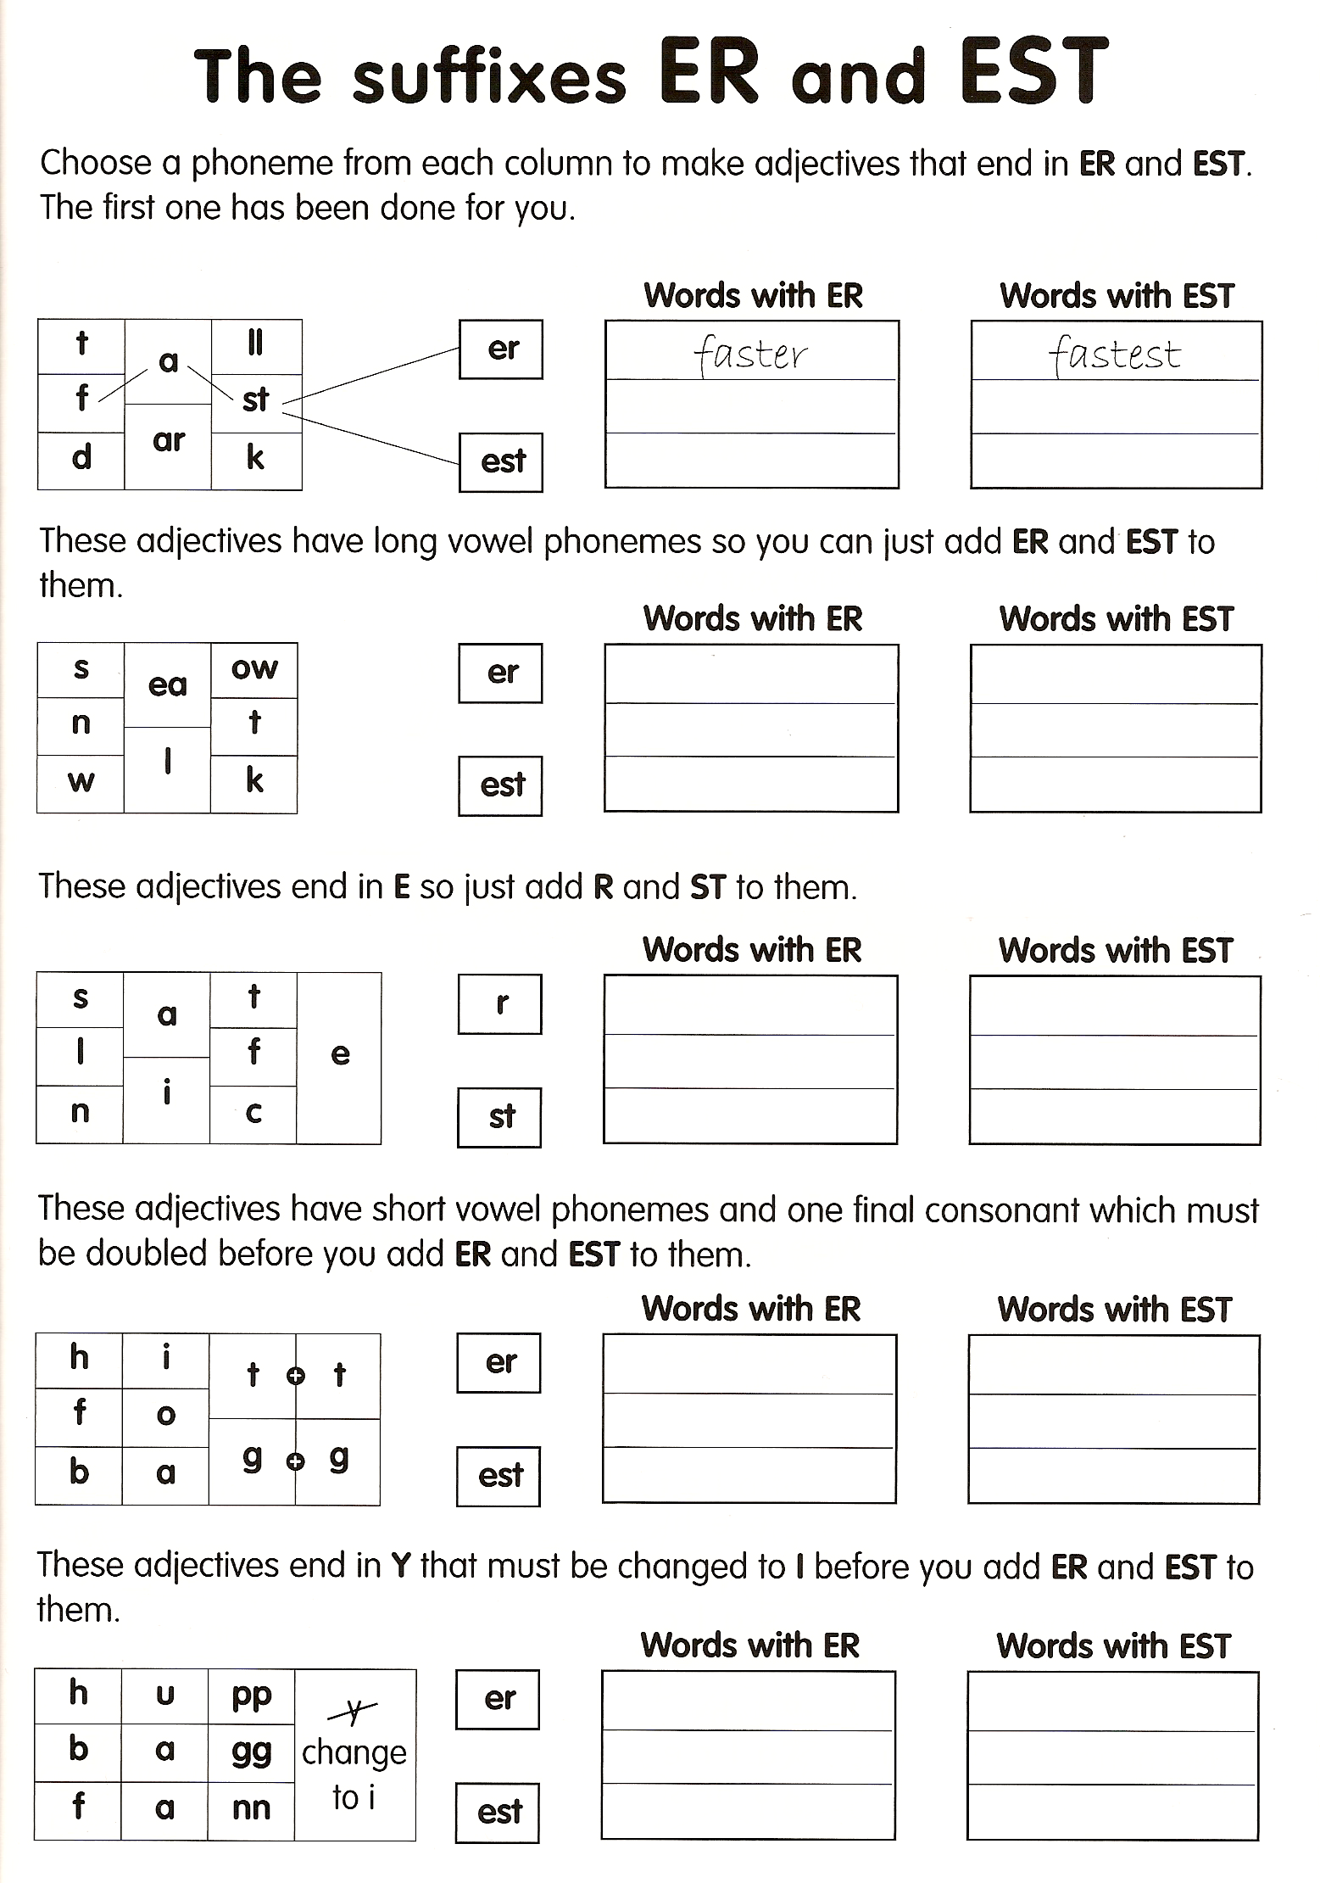

Root word | → | add ‘er’ | → | add ‘est’
fast | → | faster | → | fastest
dark | → |  | →
tall | → |  | →
slow | → |  | →
neat | → |  | →
weak | → |  | →
small | → |  | →
old | → |  | →
smart | → |  | →
cold | → |  | →
rich | → |  | →

Find ten –er and –est words hidden in the word search.

z | d | x | y | w | z | s | c | x
f | a | s | t | e | r | m | o | y
z | r | m | a | a | i | a | l | s
o | k | a | l | k | c | r | d | l
l | e | l | l | e | h | t | e | o
d | s | l | e | r | e | e | s | w
e | t | e | r | x | s | s | t | e
r | y | r | z | x | t | t | y | r

