Work Booklet –
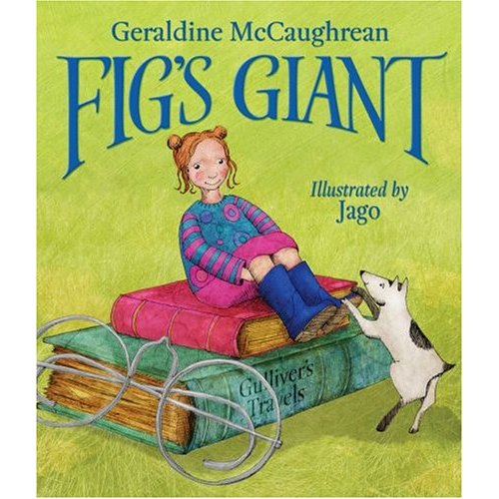

- Look carefully at the book cover, what do you think this book is going to be about? What kind of story do you expect it to be (i.e. crime, fantasy, sci-fi)? Why do you think this? (AF1)

- What point of view is the story being told from (i.e. the narrator, the main character)? How do you know? (AF1)

- Fig is scared of a lot of things, what are you scared of? (AF7)

- At the bottom of the first page, the author mentions someone called Gulliver. Who do you think this is? (AF5)

- If you spotted a giant lying on the beach, would you climb on top of him? Why/why not?

- Imagine you are Fig. Write down everything you are feeling as you run away from the giant. (AF3)

- Why do you think no-one believes Fig when she says there’s a giant on the beach? (AF3)

- Why do you think Fig is sorry she told everyone about the giant? (AF2)

- Do you think it’s right for the giant to be kept as a prisoner by the emperor? Why? (AF7)

- Which end do you open your boiled egg?

- When Gulliver turns up at school and asks Fig to come on a trip, where do you think they are going? (AF3)

- Do you think it was a good idea for Gulliver to take all the Belfuscan ships into the sea? Why/why not? (AF7)
- What do you think will happen to Gulliver now that he has refused to make the Belfuscan’s slaves? What makes you think that? (AF3)

- Was it a surprise when you found out that Fig had gone with Gulliver?

- Can you write a review for this book? You should explain what you liked or disliked about the book and whether you would recommend this book to a friend. (AF6)

