Flat Stanley
Flat Stanley
Chapter 1 Pgs 1 – 8
Correct the sentences.
- Mrs. Lambchop’s older son was called Arthur.
- Mr. and Mrs. Lambchop didn’t like politeness.
- A bread board had fallen on Stanley.
- Stanley was as flat as a table.
- Mrs. Lambchop took Stanley to the dentist.
- Stanley was four metres tall.

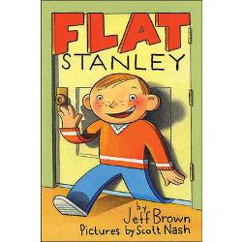

Flat Stanley
Chapter 2 Pgs 9 – 15
Choose the best word.
- Stanley (liked, hated, detested) being flat.
- Arthur was (happy, jealous, angry).
- Stanley could (walk, crawl, slide) under doors.
- Mrs. Lambchop’s (ring, scarf, necklace) fell down a grating.
- Stanley made a rope out of (leaves, string, laces).
- The policemen thought Stanley’s mum was (happy, mad, angry).

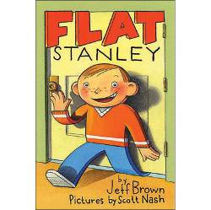

Flat Stanley
Chapter 2 Pgs 16 – 22
Write out the sentences in the correct order.
- Stanley slid into the envelope.
- It was an invitation to California.
- They put Stanley in the post box.
- They put lots of stamps on it.
- Stanley got a letter from his friend.
- Mr. Lambchop came home with a big brown envelope.

Flat Stanley
Chapter 3 Pgs 23 – 28
Fill in the missing words.
- Mr. Lambchop took the boys to the park on __________.
- Mr. Lambchop __________ Stanley up to keep him safe.
- Mr. Lambchop’s friend thought that Stanley was a roll of __________.
- It __________ on the way to the park.
- Arthur __________ encyclopaedias on top of himself.
- He felt __________ of Stanley.
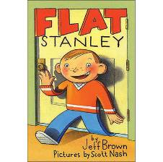

Flat Stanley
Chapter 3 Pgs 28 – 34
Match the halves of the sentences.
- Boys were flying
- Arthur wanted to
- Arthur borrowed
- He made himself into
- Arthur left the spool
- Stanley got caught
fly a kite too. kites in the park. in the branches. a kite for Arthur. a large spool of string. wedged in a tree.
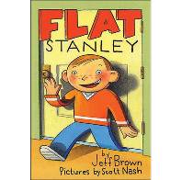

Flat Stanley
Chapter 4 Pgs 35 – 46
True, false or can’t tell?
- Mr and Mrs Dart lived in Flat 16.
- Mr. Dart worked in the art museum.
- Mr. Dart was usually bad tempered.
- The stolen painting was worth £1000.
- Stanley took a long nap so he could stay awake.
- Stanley disguised himself as a policeman.
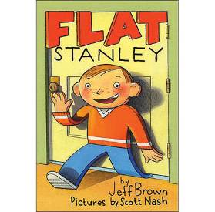

Flat Stanley
Chapter 4 Pgs 46 – 54
Sort out the muddled sentences.
- in was dark It hall. very the
- through trap The came men door. a
- called and thieves The were Max Luther.
- the shouted Stanley at loudly thieves.
- in police. the Mr came Dart with
- next The medal. Stanley a day got
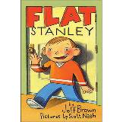

Flat Stanley
Chapter 5 Pgs 55 – 65
Who said these things?.
- “Shame on them,” said ________.
- “Are you OK?” asked ________.
- “Don’t talk about what I just said,” asked ________.
- “I’m tired of being flat,” said __________.
- “We heard you,” said ________.
- “I blew him up,” said ________.
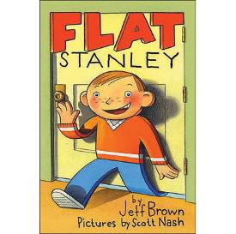

FLAT STANLEY

by Jeff Brown
