Floppy’s Phonics Stage 3 “The Rook and the Ring”

Name............................................................. Room.............................................

Word List

Read the words to your teacher.

|  |  |  |  |
| --- | --- | --- | --- |
| rook | ring | and | sing |
| look | that | wing | took |
| the | will | die | Let’s |
| tie | Its | looks | good |
| cooking | pie | off | magpie |
| out | went | wood | tree |
| shot | book | cook | food |
| lie | hood | moon | pill |
| noon | spoon | soon | spill |

C:\Users\Eve\AppData\Local\Microsoft\Windows\Temporary Internet Files\Content.IE5\39XIXXBW\MC900098039[1].wmf

Well done!!!

Tricky words

rook ________________ _________________ ________________

ring ________________ _________________ ________________

the ________________ _________________ ________________

that ________________ _________________ ________________

wing ________________ _________________ ________________

tie ________________ _________________ ________________

said ________________ _________________ ________________

good________________ _________________ ________________

When you have read the words three times to your teacher you can colour in the box.

|  |  |  |  |
| --- | --- | --- | --- |
| rook |  |  |  |
| ring |  |  |  |
| the |  |  |  |
| that |  |  |  |
| wing |  |  |  |
| tie |  |  |  |
| said |  |  |  |
| good |  |  |  |

Sounds to think about:

oo

Say and write the words;

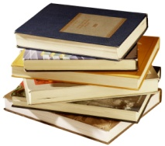

books _____ ______ ______

C:\Users\Eve\AppData\Local\Microsoft\Windows\Temporary Internet Files\Content.IE5\U8UCONC8\MC900295723[1].wmf

cook ______ ______ ______

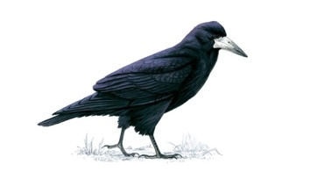

rook ______ ______ _______

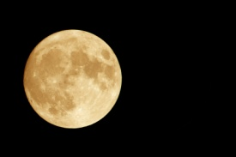

moon ______ ______ ______

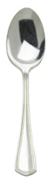

spoon ______ ______ ______

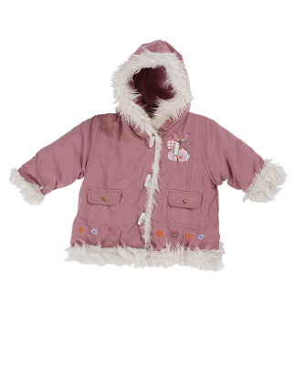

hood _______ ______ _______

Pages 1-5 Choose the correct word.

A rook sat on a _________ pot / spot.

“Oh, look at that _______ book / rook.

It had a bad _______ sting / wing.

Mum took the ______ food / rook.

“ Let’s call him ______ Don / Ron.

Draw the picture of the rook on page 1.

Pages 8- 11

Put the story in order.

|  |
| --- |
|  |
|  |
|  |
|  |

|  |
| --- |
| Mum ran out. |
| Mum was cooking. |
| A magpie took the ring. |
| Mum took off her ring. |

Who said it?

Look at that wing.

Page 2

_________________

No, I can tie the wing up.

Page 5

____________

Page 11

A magpie took my ring!

____________

My ring is in that tree.

Page 13

__________

It’s Ron the rook.

Page 11

____________

Page 16 “Well, well. I got my ring,” said ________________.

Pages 16

Ron is a good rook.

_______________________

Page 16

Draw the picture and label it.

Chip Dad Biff Floppy Mum Ron

Pages 12 - 14

Unscramble the sentences.

ran. and Dad Mum

Chip, Floppy and ran. Biff

___________________________________________________________

wood. magpie went The a to

Page 14 – 15

What did Chip and Biff say?

Pages 12 – 15

|  |
| --- |
|  |
|  |
|  |
|  |

|  |
| --- |
| The magpie went to a wood. |
| Mum and Dad ran. |
| The magpie shot off. |
| Ron the rook got the ring. |

Look at the pictures.

Yes or No?

A **book** sat on a pot. ________

**Chip** got Mum and Dad. ________

**Dad** took the rook. ________

Biff and **Mum** fed Ron the rook. ____________

**Biff** let the rook go**.** _________

**Mum** took off **her** ring. ___________

...................................................................................................................................

Draw Mum cooking. (page 10)