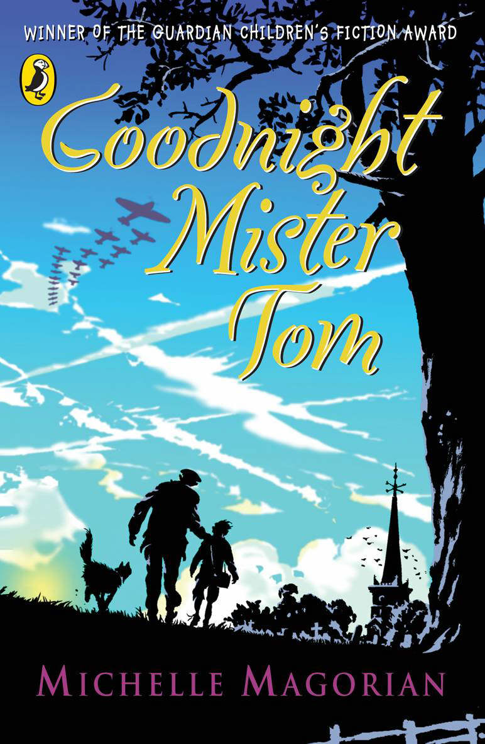
‘Goodnight Mister Tom’ by Michelle Magorian

Read Chapters 1 & 2 and answer the following questions:

1) Draw and label a map of Little Weirwold. Make sure you include all the parts of the village that you think are, or will be, important to Tom and Willie.

Read Chapters 3 & 4 and answer the following questions:

2) Create a mind map showing everything we know about Tom. Think about everything we have found out about him over the last four chapters, such as;
- his family & friends - significant events
- his education - how others see him
- hobbies & interests - his hopes and wishes

Read Chapters 5 & 6 and answer the following questions:

3) Think of the differences between Willie’s life in London and Willie’s life in the Country. Imagine you are an evacuee like him and write a letter home to your family in London. Tell them of all the different things you have done since you arrived in the country, that you wouldn’t do at home in London.
Read Chapters 7 & 8 and answer the following questions:

4) Create a mind map showing everything we know about Willie, just like we did for Tom for the second task.

Read Chapters 9 and answer the following questions:

5) Imagine you are Willie and it has just been your birthday. Happy Birthday! Just before you go to bed you write about your day in your diary, make sure you include your thoughts and feelings, not just what happened.

Now read Chapter 10.

Read Chapters 11 & 12 and answer the following questions:

6) What other names is Willie known as? Who calls him these?
7) What is Tom’s surname?
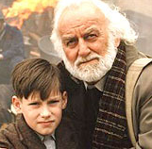
8) What character is Willie asked to be in the play?
9) What were the names of Tom’s wife and child?
10) Why do you think Willie has finally stopped wetting the bed?
11) What information do we have about Willie’s mum? What do you think she is like?
Read Chapters 13 & 14 and answer the following questions:

12) Write Willie’s name in the middle of your page. Write as many characters names as you can think of around his name. Depending on their relationship with Willie place their names close or far away from his. For example, if you think Zach and Willie are strangers then place Zach’s name far away from Willie’s. You can join the names together with lines and draw arrows on the lines if you think they are becoming closer or drifting away.

Read Chapters 15 & 16 and answer the following questions:

13) Draw two pictures of Willie; one of him in London and one of him the Country. What will be different about them? Think about his appearance and facial expressions.

14) Think very carefully about what you think Tom and the policeman will find behind the door. You don’t need to write or draw anything, but you can share your ideas with me or your friends if you would like to.

Read Chapters 17 & 18 and answer the following questions:

15) These chapters are very emotional. Explain how you felt when you read them. Were there any specific parts that stick in your mind?
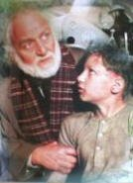
16) How do you think the author has conveyed emotion in the past few chapters? Try to quote some of the words and sentences as evidence.

Read Chapters 19 & 20 and answer the following questions:

17) Go back to your mind maps of Tom and William. Can you add anything else to them? Think about how the characters have changed throughout the story. How are they different now compared with what they were like in the first chapter?

Read Chapters 21 & 22 and answer the following questions:

18) Imagine you are William and have been told the news about Zach. What special thing do you think you could do to keep the memory of Zach alive and celebrate the wonderful friendship you had? Write about it or draw a picture to describe what you would do. It can be anything you want!
19) What clues does the author give us to let us know that William is happy and settled in his new life with Tom? Try to quote some of the text as evidence.

Read Chapter 23 and answer the following questions:

19) Write a book review ‘Goodnight Mister Tom’.

