C:\Users\Gareth\AppData\Local\Microsoft\Windows\Temporary Internet Files\Content.IE5\OZC4LF4L\MC900412498[1].wmfL/O To improve my vocabulary.

Name__________________________________

Use the words in the box at the bottom of the page to fill in the missing

words in the sentences.

Then use a thesaurus to find a more exciting word choice!

1. Shining brightly, the _ o _ sun shone over Athens.
2. The _ c _ _ _ Hydra slithered menacingly towards Theseus.
3. C:\Users\Gareth\AppData\Local\Microsoft\Windows\Temporary Internet Files\Content.IE5\OZC4LF4L\MC900414940[1].wmfP _ _ _ _ _ Persephone had golden hair like a bright ray of sunlight.
4. Laughing loudly, the King of Athens was very _ _ _ p y.
5. Apollo, who was very _ t _ _ _ _ , lifted the heavy golden sword.
6. Locked in the dingy underworld forever, Hades felt very _ _ d.
7. 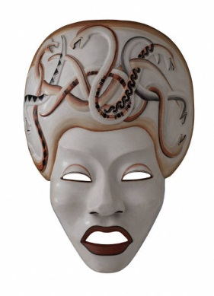The Minotaur, who was very _ _ g , towered over Theseus like a skyscraper.
8. Jason got to his feet and began to w _ _ _ towards the golden fleece.
9. Perseus h _ _ Medusa and knocked the gorgon to the stony ground.

walk hot scary big

pretty sad happy strong hit