L.O: To use index and contents page to locate keywords and information. (O/R)  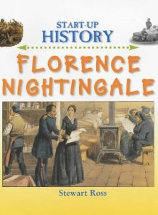  Florence Nightingale  - If you wanted to use the ‘index’, which page would you turn to?  ____________________  - If you wanted to find out about ‘nurses’, which pages would you turn to?  ____________________ Contents page / Index (circle one)  - If you wanted to find out about ‘Florence and the horrible hospital’, which page would you turn to?  ____________________ Contents page / Index (circle one)  - If you wanted to find out about ‘Florence Nightingale, a Famous nurse’, which page would you turn to?  ____________________ Contents page / Index (circle one)  - If you wanted to find out about Florence Nightingale’s ‘birth’, which page would you turn to?  ____________________ Contents page / Index (circle one)  - If you wanted to find out about ‘The story of Florence Nightingale’, which page would you turn to?  ____________________ Contents page / Index (circle one) | L.O: To use index and contents page to locate keywords and information. (G)  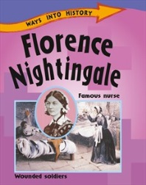  Florence Nightingale  - If you wanted to use the ‘index’, which page would you turn to?  ____________________  - If you wanted to find out about ‘Lady with the Lamp’, which page would you turn to?  ____________________ Contents page / Index (circle one)  - If you wanted to find out about ‘hospitals’, which pages would you turn to?  ____________________ Contents page  ____________________ Index  - If you wanted to find out about ‘soldiers’, which pages would you turn to?  ____________________ Contents page  ____________________ Index  - If you wanted to find out about ‘The Crimean war’ which page would you turn to?  ____________________ Contents page / Index (circle one)  - If you wanted to find out about ‘The Crimean war’ which page would you turn to?  ____________________ Contents page / Index (circle one)
L.O: To use index and contents page to locate keywords and information. (Y/B)  The Great Fire of London  - If you wanted to find out about ‘The Great Fire of London’ which page would you turn to?  ____________________ Contents page / Index (circle one)  - Can you find out about ‘Samuel Pepys’ on page 6? _________  Which pages would you turn to, if you wanted to find out about ‘Samuel Pepys’?  ____________________ Contents page / Index (circle one)  - If you wanted to find out about ‘Trying to put out the fire’, which page would you turn to?  ____________________ Contents page / Index (circle one)  How did people put out the fire?  _______________________________________________________________  _______________________________________________________________  - Can you find out about ‘After the Great Fire’ on page 8? _________  Which page would you turn to if you wanted to find out about ‘After the Great Fire’?  ____________________ Contents page / Index (circle one) | - If you wanted to find out about ‘Pudding Lane’, which pages would you turn to?  ____________________ Contents page / Index (circle one)  What happened in ‘Pudding Lane’?  _______________________________________________________________  _______________________________________________________________  - If you wanted to find out about ‘Monument’, which pages would you turn to?  ____________________ Contents page / Index (circle one)  When and why was the ‘Monument’ built?  _______________________________________________________________  _______________________________________________________________  - If you wanted to find out about ‘How did the Great Fire start?’ which page would you turn to?  ____________________ Contents page / Index (circle one)  How did the Great Fire start?  _______________________________________________________________    

