

Name ________________

**Freaky Fish**

Stage 8

* Use the **Contents Page**

|  |  |
| --- | --- |
| Name of Fish | page |
| Porcupine fish |  |
| Moray Eel |  |
|  | 18 |
|  | 22 |
| Seahorse |  |

* Use the text on pages 18 - 19 about seahorses to decide if the statement is true or false.

|  |  |  |
| --- | --- | --- |
|  | True | False |
| Seahorses come in different shapes and sizes. |  |  |
| Its skeleton is on the inside of its body. |  |  |
| It carries its young in a pouch. |  |  |
| The male seahorse gives birth to the young. |  |  |
| They do not eat crabs. |  |  |
| The seahorse can hold onto things with its tail. |  |  |

* Complete the table

|  |  |  |
| --- | --- | --- |
| Name | Habitat | Food |
| Porcupine fish |  |  |
| Stargazer |  |  |
| Trumpet fish |  |  |
| Treefish |  |  |
| Lionfish |  |  |
| Moray Eel |  |  |
| Seahorse |  |  |
| Sarcastic fish |  |  |
| Sculpin |  |  |

* Write a fact about each of these fish.

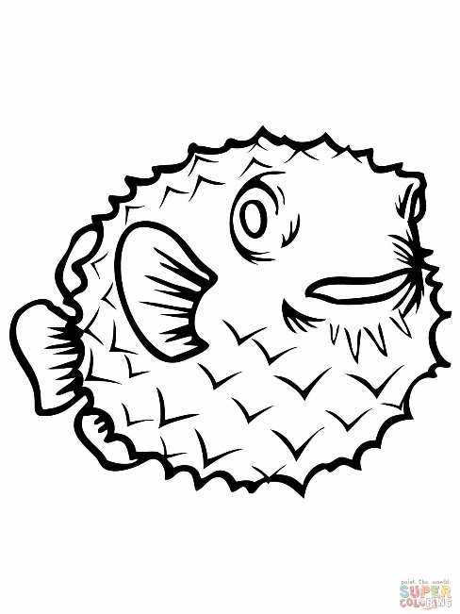

Porcupine Fish - _______________________________

______________________________________________________________________________________

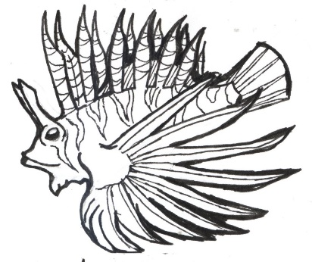Lion Fish - _______________________________

______________________________________________________________________________________