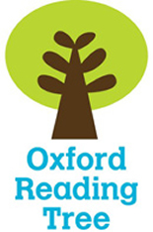

Name ________________



Musician Vanessa-Mae

Stage 8

* Use the contents page.

|  |  |
| --- | --- |
|  | Page |
| How a violin is made? |  |
| Vanessa-Mae’s concerts |  |
| Making a CD |  |
| How to play the violin. |  |

* Find 6 proper nouns on page 3.

|  |  |
| --- | --- |
|  |  |
|  |  |
|  |  |

* Use the Index.

|  |  |
| --- | --- |
|  | Page numbers |
| Mozart |  |
| orchestra |  |
|  | 8 |
|  | 21 |

* Complete these sentences.

1. Violins are made from ­­­­__________.
2. Maple and Spruce are used because they are __________.
3. Makers often drop the wood to test for the ___________ it makes.
4. The only part of a violin that is not needed for the sound is the ­­­­­ ___________.

* Label the violin

|  |  |  |
| --- | --- | --- |
| scroll | tuning pegs | bridge |
| chin rest | strings | bow |

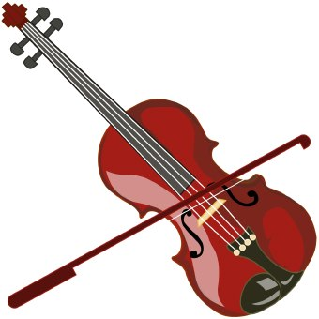

* Read Vanessa-Mae Performs on pages 8-9.

|  |  |  |
| --- | --- | --- |
|  | True | False |
| Vanessa-Mae hates chocolate. |  |  |
| She always drinks water before a performance. |  |  |
| She plays in pop bands and with orchestras. |  |  |
| Orchestras have 20 violinists. |  |  |