The Egg Hunt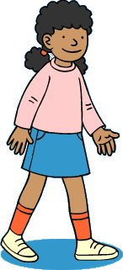
- Who came to stay? (page 1) _________________________________
- Where did Wilma go? (page 6) _________________________________
- Name 2 places where Wilma hid the eggs. (page 8 + 9) __________________________________________________________________
- Who had the eggs? (page 14) _________________________________

Answer box:
- The squirrels
- The park
- In the trees and flowers.
- Kate

