Work Booklet –

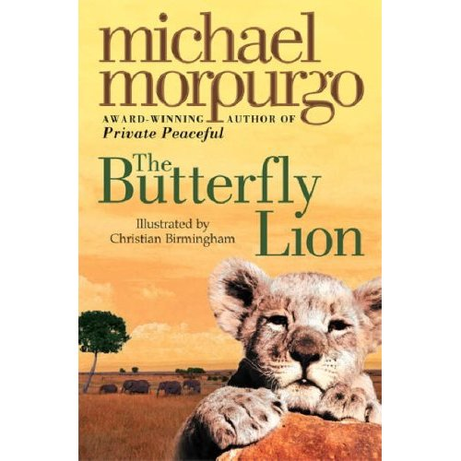
- Look carefully at the book cover, what do you think this book is going to be about? What kind of story do you expect it to be (i.e. crime, fantasy, sci-fi)? Why do you think this?

- Look back over the chapter you are reading. Can you select five powerful words that you could use in your own writing? Write them down.

- At the beginning of ‘Chilblains and Semolina Pudding’, the narrator talks of the Butterfly Lion. Draw a picture of what you imagine him to look like.

- Draw a picture of, what you think, the main character looks like. Write down words around the outside of your drawing which describe how the narrator feels in the first chapter.

- What would you do if you were being bullied at school? Explain your answer.

- In ‘Strange Meeting’ the narrator meets an old lady. What is she like? Draw a picture of her and write words to describe her around the outside.

- During this chapter, the old lady mentions a person called Bertie. Who do you think Bertie is and what relation could he be to the old lady?

- Write a diary entry from the point of view of a character of your choice. It should include something exciting which has happened that day.

- Look back at your original picture of the Butterfly Lion. Now you know what the Butterfly Lion is, does your picture reflect that? Write a short description of the Butterfly Lion, using the book to help you.

- The chapter ‘Timbervati’ takes the story to a different place. What has the author done?

- The characters have also changed. The main character is now Bertie, not the narrator. Do you think there will be similarities in the characters? Give reasons for your answer.

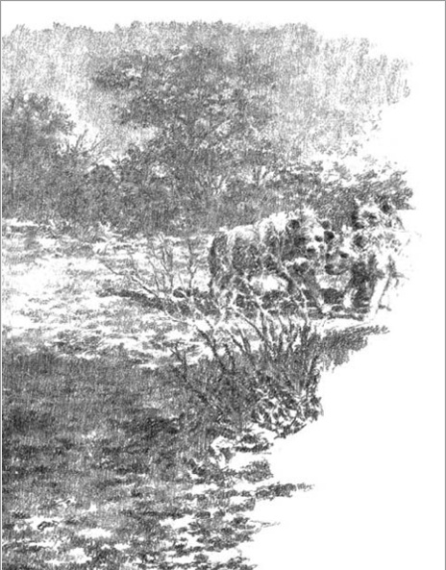

- After reading ‘Timbervati’, write a diary entry from Bertie’s point of view. Remember to use the book to help you.

- Imagine the lion was yours. Would you name him? If so, what name would you give him? Why?

- Do you think that setting the lion free was the best thing for Bertie to do? How do you think his Dad will react?

- How do you think you would feel if your life suddenly changed dramatically? Would you be as calm as Bertie if you were being shipped to boarding school on the other side of the world?

- After reading the chapter ‘And All’s Well’, do you think that Bertie and Millie will ever see each other again? What war do you think the author is referring to? Give a reason for your answer.

- In the chapter ‘A Lot of Old Codswallop’, what do you think the old lady means by ‘They’re the same. The lion out there on the hillside and the lion in the story. They’re the same.’? How can they be the same?

- Why do you think the German’s stopped firing when Bertie waved his hands in the air?

- Write a diary entry for Bertie about the day he set eyes on the lion again. You should include feelings and a description of the day.

- Imagine you are a newspaper reporter at Dover docks when the lion comes off the ship. What would your headline be?

- The twist in the chapter ‘And the Lion Shall Lie Down with the Lamb’ was very surprising. How do you think the whole day happened? (i.e. was it a dream?)

- Write a detailed book review. It should include:
- Why you liked/disliked the book;
- Relationships between characters;
- And, finally, would you recommend this book to a friend? Why/why not?

