The Colour of Darkness

His cloak was a dark brooding shadow
His smile was white pure ice
His thoughts were black, they were icy depths
And his eyes flashed sea green blue

Her rosebud mouth was a dawning new pink
As she wrapped round a coat of silver
Her eyes were alight, they were greyest new skies
And she ran through the gathering gloom

Too late! He was there
A flash of brown light
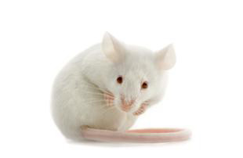
A hunter with weapons of fur
As the cat caught the mouse
With her coat pale and ice
He gently began to purr
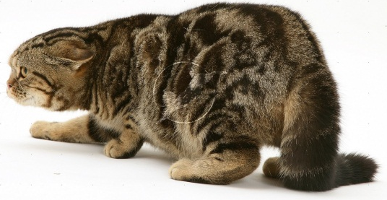

The Colour of Darkness

His cloak was as dark as the shadows
His smile was as white as the ice
His thoughts were as black as the icy depths
And his eyes were as green as the sea

Her rosebud mouth was as pink as the dawn
As she wrapped round a coat as of silver
Her eyes were alight like the greyest new skies
As she ran through the gathering gloom

Too late! He was there
Like a flash of brown light
A hunter with weapons of fur
As the cat caught the mouse
With her coat pale as ice
He gently began to purr

LO: I can write a personification poem about colours using similes

