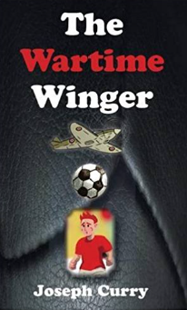

Hi – my name is Joseph Curry, teacher and author of the Wartime Winger, a WW2 novel published by Mogzilla. I have written some questions that are designed to support teachers with whole class when reading my book. They vary in difficulty but are most suitable for pupils from yr 3 to yr 5. With whole class reading, the emphasis is on more reading, less analysis so ideally a teacher would select one or two questions from each chapter. Of course, they can also be used as a traditional comprehension exercise. Hope they prove useful.

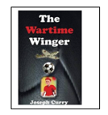
The Wartime Winger – Chapter 1

- p3 – Find and copy two words that describe the old man’s eyebrows. (2 points)

- P3 – Use a dictionary to find out the meaning of the word resentment. (1)

- P4 – Explain why school was a disappointment for Liam. (2)

- P5 – What did Mr James warn Liam about? (1)

- P5 – Explain why Liam didn’t like Morgan Harris applauding his shots. (2)

- P6 – Why do you think Liam began lashing the ball against the wall? (1)

- P6 – Why did Liam hesitate before climbing over the fence to retrieve his ball? (1)

- P6 – Summarise the chapter you have just read. Try and use three or four key points. (3)

- P7 - Why did the old man think that Liam was crazy? (1)

- P7 – Why do you think the old man seemed frightening to Liam? (2)

- P8 – Why are the sofa and chairs in the house compared to the old man? (2)

- P9 – Why don’t the old man’s children live with him anymore? (1)

- P9 – What do you think makes Liam a little less scared of the old man? (2)

- P10 – Why did Liam feel a sharp prickle of shame? (2)

- P10 – What advice did the old man give Liam about playing football? (2)

- P10 – What do you think made Stan the bravest person the old man knew? (2)

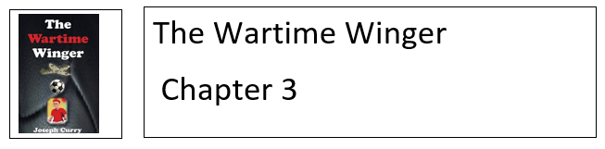

- P11 – Why do you think that Jimmy was picked on by Billy Graham? (2 points)

- P12 – Find evidence from the text on this page that shows you Stan was a stronger boy than Jimmy. (1)

- P13 – How did Stan prevent Jimmy from being hurt any further. Explain in your own words. (2)

- P13 – The woman in the first aid room was gentle. Agree/Disagree – Use evidence from the text to support your reasoning. (2)

- After reading the whole chapter, explain why Jimmy told Liam that being punched in the face at school was the best thing that had happened to him. (2)

- P15 - Describe two ways in which Jimmy was left to ‘fend for himself’. (2 points)

- P15 – What did Stan mean when he stated that a gust of wind would sweep Jimmy off his feet? (1)

- P16 – Quote directly from the text to show that Jimmy’s mother looked tired. (2)

- P17 – Explain the reasons why you think Jimmy’s mother lashed out at him. (2)

- P18 – Explain why you think Jimmy thinks of Stan as a good friend. What are his best qualities? (3)

- P18 – What do you think Jimmy means when he describes Stan’s boiling point? (1)

- P19 – What do you think worried Stan about the World Cup being held on the other side of the world? (1)

- P20 - Name three things that Jimmy and Stan learnt about in school. (3 points)

- P21 - You have to do things that other people aren’t willing to do! Why do you think this part of the text is in bold? (1)

- P21 – Why was the hillside path described as dreaded? (1)

- P22 – Explain why people dived into the pool to rescue the boys. (2)

- P22 - Use a dictionary to look up the word meticulous and explain what it means. (1)

- P22 - What would you like to succeed at? Describe how you would practise the skills you would need. (2)

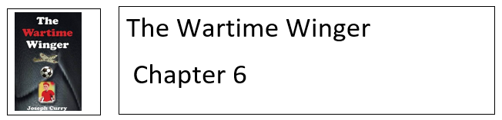

- P23 - Before the match, why does Jimmy compare his mood with the sky outside? (2 points)

- P23 – Use evidence from this page to explain how Jimmy and Stan are very different. (2)

- P24 – Find three pieces of text that show that Jimmy didn’t enjoy the first half of the big match. (3)

- P25 – Why was Jimmy surprised that Stan was angry? (1)

- P25 – What does Jimmy mean when he describes Stan’s words ringing in his ears? (2)

- P26 – Find and copy the passage of text which makes the rain seem like an angry person. (1)

- P27 -Explain why Jimmy sank to the turf in dejection. (2)

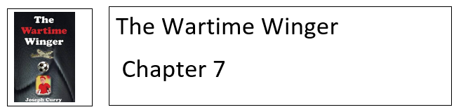

- P28 - Where did Jimmy and Stan end up working? (1 point)

- P29 - How had Adolf Hitler caused controversy at the Olympic games? (1)

- P29-30 What Olympic event would you like to watch or participate in? Explain your reasons. (2)

- P29-30 – Why was there no more Olympics for twelve years? (1)

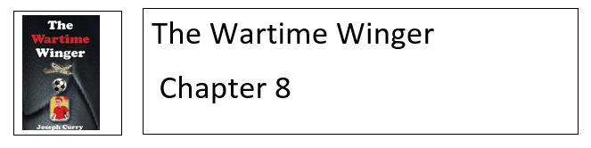

- P31 – Why did Jimmy tell Liam to go easy on the chips? (1 point)

- P32 – Describe three things that were surprising about Liam’s day at school. (3)

- P33 – Explain in your own words how Jimmy makes Liam laugh on this page. (2)

- P34 – What does Jimmy mean when he tells Liam that his story won’t always be a smooth ride? (2)

- Summarise what has happened in the story up until this point. (3)

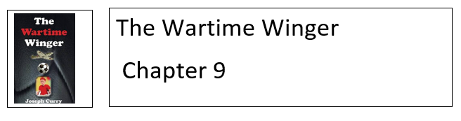
- P35 - Why did it make Jimmy smile to see Stan so tense? (1 point)

- P35 – Why did Stan joke about Jimmy being captain of the team? (1)

- P36 – Explain why Jimmy looked different to most of the other players. (2)

- P36 – Describe how Jimmy has changed since he first met Stan. (2)

- P36 – What does Jimmy mean when he describes receiving a traditional welcome from the opposition? (2)

- P37 – Why do you think the word ‘erupted’ has been chosen to describe the crowd? (2)

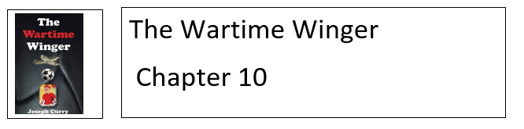

- P39 - Why does Jimmy describe his wages as a princely sum? (2 points)

- P39 - Describe two reasons why Jimmy had a spell out of the team. (2)

- P40 - Jimmy thinks Stan is a good penalty taker. Agree/Disagree. Support your reasons using evidence from the text. (2)

- P41 – Why did Jimmy head towards the kitchen sink? (2)

- How do you think Jimmy felt when Neville Chamberlain declared war on Germany? (3)

