Where is your story set?

in school

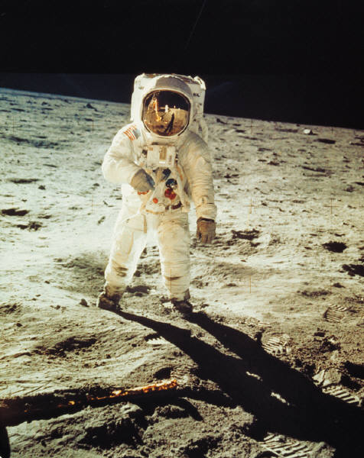
on the moon

on a ship

in a castle

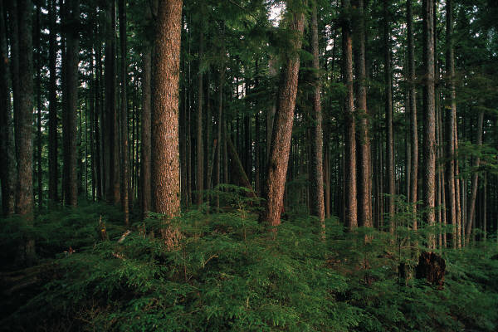
in the woods

on an island

under a bridge

in a playground

on a spaceship

in a palace

in the jungle

in my bedroom

