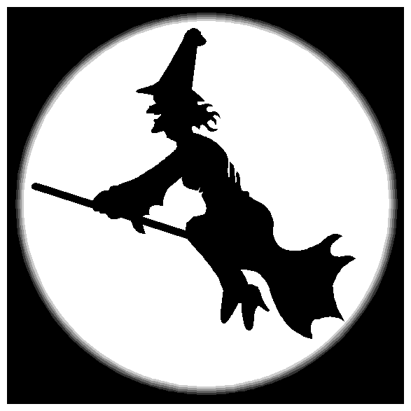 Which witch is which?
Name………………………………………………..

Date…………………………………………………

A witch is a woman who wears black clothes, casts spells and rides a broomstick. (Like Mildred Hubble in ‘The Worst Witch.)

Which is a question word, about making a choice. (e.g. Which is your book?)

Fill in the missing witch/which.

- …………….. is your classroom?

- I saw a ……………………. with a black cat.

- My mum asked …………. is my favourite book.

- I want to know ……………….. character in the story is the best.

- Miss Hardbroom is a very wicked …………………….

- I wonder …………………… way it is to the shops?

- The ……………… had long finger nails.

- Nina dressed up like a …………………. for Halloween.

9. ……………… way did the little……………….. fly on her broomstick?

- ………………….. …………………… is the naughty one in ‘The Worst ……………….’ story?

Now make up two of your own sentences using which and witch.

11. ……………………………………………………………………….

12. …………………………………………………………………………..

