Word Ladder
the
to
I
no
go
into
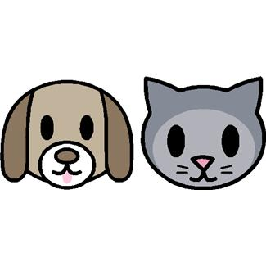
Phase 2 Tricky HFW
Word Ladder
of
off
on
can
dad
had
back
and
Phase 2 Decodable 2 HFW

Word Ladder
get
big
him
his
not
got
up
mum
but
put
Phase 2 Decodable 3 HFW

Word Ladder
a
an
as
at
if
in
is
it
Phase 2 Decodable 1 HFW

