Word Ladder
went
it’s
from
children
just
help
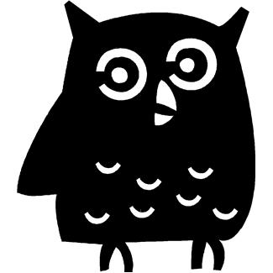
Phase 4 Decodable HFW
Word Ladder
said
have
like
so
do
some

come
Phase 4 Tricky HFW

Word Ladder
were
there
little
one
when
out
what
Phase 4 Tricky HFW

