9 WRITING OPENERS
Open with dialogue  Start a conversation between two characters | Open by describing a character or setting  Use adjective, paired adjectives, similes and powerful verbs |  | Open with a question  Ask the reader a question
Open with a quotation | 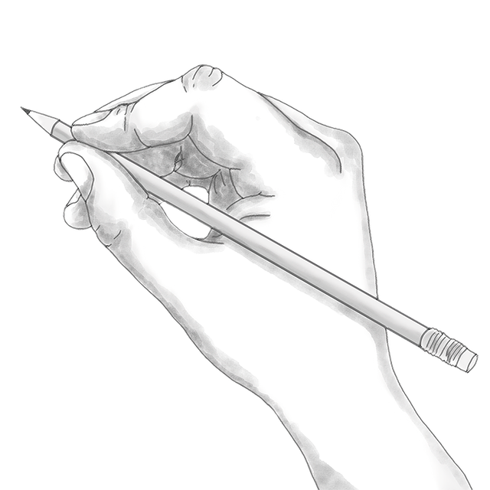 |  | Open with a riddle or humour
Open with a sound  Use onomatopoeia |  |  | Open with a bold statement or fact
Open with how you felt or a feeling |  | Open with a personal experience

