Year Three Unit 3 Mystery and Adventure Story Support Card

Imp or Pixie 

fast speedy quick nimble

light sharp pointed features

slight slim hopping bright neat



clever wise gentle

helpful skilful shy bashful

brave moody dreamy naughty

playful mischievous

Year 3 Unit 3 Adventure and Mystery Story Support Card

Princess or girl

pretty beautiful fine

tall lovely elegant fair-haired dark

graceful delicate blond petite

kind gentle sincere caring

helpful lonely happy/unhappy

sweet thoughtful afraid/unafraid

considerate generous

Year Three Unit 3 Mystery and Adventure Story Support Card
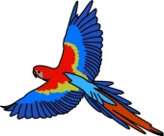
Animal or Bird

fast speedy quick fine

elegant slow plodding scruffy

graceful feathered rough haired wide

eyed

clever wise gentle

helpful skilful shy brave

shy afraid/unafraid

fierce dreamy naughty playful

