England

Flag of England
Sometimes flown together with the United Kingdom flag
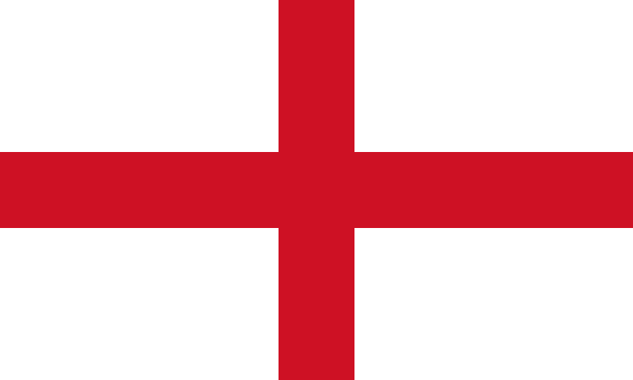
Public domain

What is the difference between England and the United Kingdom?
England is a country that is part of the United Kingdom.
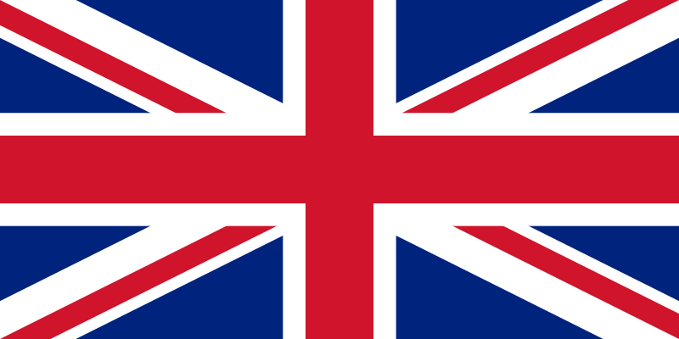
Flag of the United Kingdom
Public Domain

Countries that make up the United Kingdom
England
Scotland
Wales
Northern Ireland
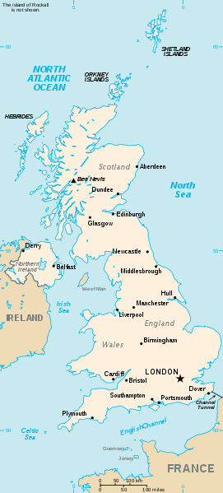 Public Domain
Map of the United Kingdom

Cities in England
London
Liverpool

Rivers in England
River Thames in London
River Tyne

Language spoken in England
English is spoken by most people. Scots and Polish are also spoken by many other people.

Currency of England
Pound
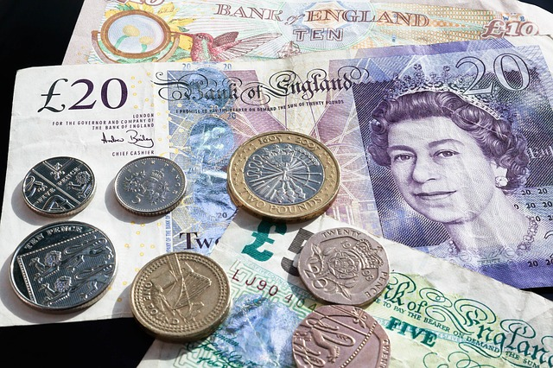
CC0 Public Domain

Countries close to England
Ireland
France
Belgium
Spain

Famous people from England
Past
The Beatles, who came from Liverpool
Princess Diana
William Shakespeare

Present
Queen Elizabeth II
Prince William and his family

Popular foods of England
Roast beef and Yorkshire pudding is a very traditional English Sunday family lunch. Yorkshire pudding is not a dessert but something that is part of a main course. It is made from flour, eggs, and milk. It is baked in the oven and served with gravy. Leftover Yorkshire pudding from the main meal can be served with ice cream and jam. Do you know what jam is? Some countries do not use the word jam but call it jelly.
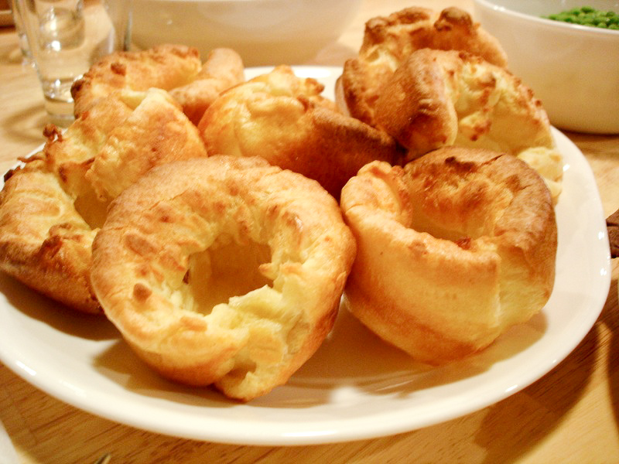
Yorkshire pudding
Creative Commons Attribution 2.0 Generic

Architecture of England
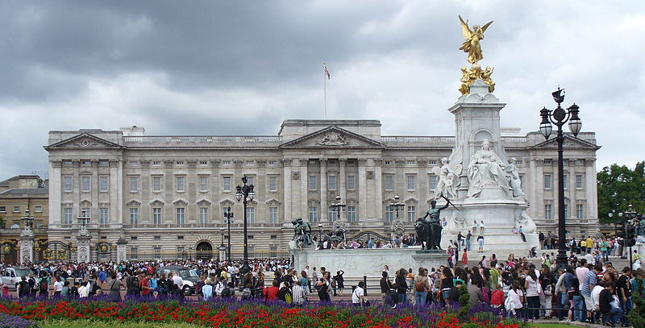
Buckingham Palace
Public domain

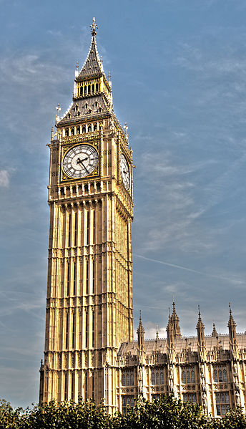
Big Ben
Photo by Berit Watkin, CC-BY-2.0

Animals of England
Wild foxes and rabbits are often seen. Badgers, weasels, and hedgehogs can also be found but are not seen as often as rabbits. Big animals like elephants, lions, and tigers can only be seen in a zoo, as England mainly has small animals. Roe deer and red deer are found, as well as a red squirrel.

White Cliffs of Dover
England is known for the White Cliffs of Dover, which can be seen along the English coastline.
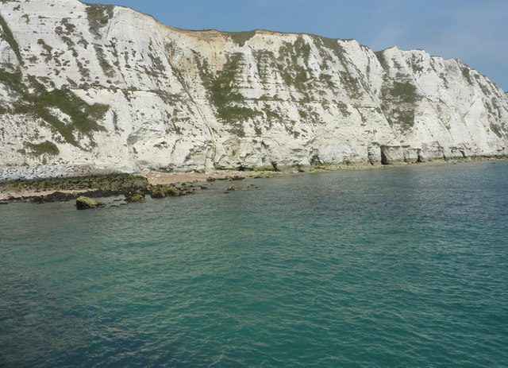
Copyright Pam Fray, CC BY-SA 2.0

Means of transport within the country
Most people travel by car, taxi, bus, or train. Use of the Underground that runs in London is a popular way to travel.

How could you reach England from where you live?

