

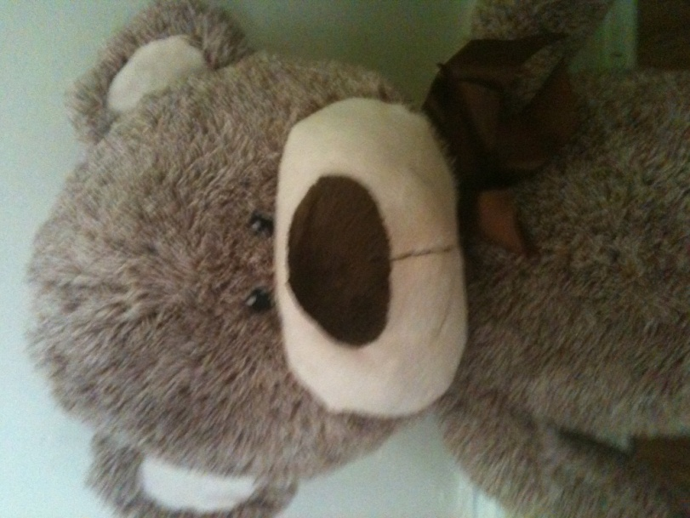

**PASSPORT NUMBER:** 00003434

United Kingdom of Great Britain and Northern Ireland

PASSPORT

SURNAME

**BEAR**

FIRST NAME

**COLUMBUS**

PLACE OF BIRTH

**\*\*\* PRIMARY SCHOOL**