Ancient Egyptian Gods

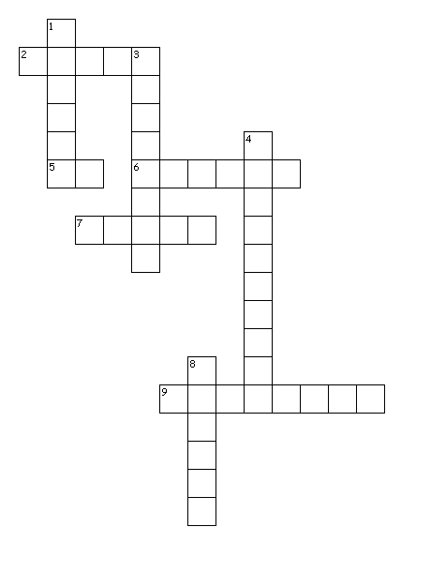
Across
2. Isis used this to help people in need
5. The sun God
6. Isis had a headdress in the shape of this
7. The God of the sky
9. Osiris was wrapped in these
Down
1. The Goddess of love and joy
3. Jackals were often seen in this place
4. Osiris ruled this place
8. Animal similar to a wild dog

