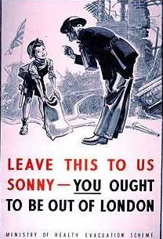
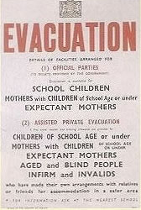

Why was evacuation introduced by the Government?
Who was evacuated?

How were they evacuated?

Where were they evacuated to?

When were they first evacuated?

When were they evacuated again?

How many people were evacuated during the war?

What was it like for a child to be evacuated?

