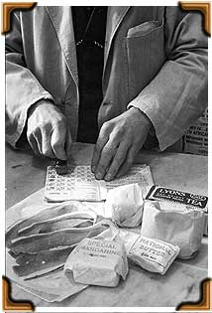
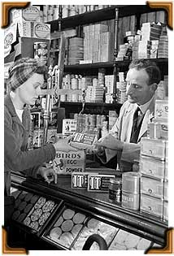
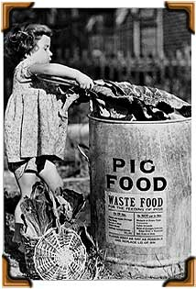
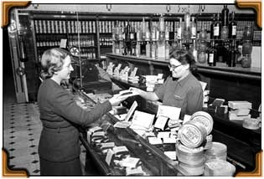
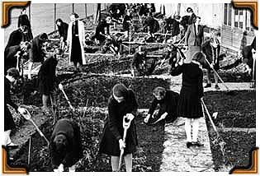
Food had to be rationed during the war and people had to get their ration book stamped by the shopkeeper. Why do you think this was? Answer fully.

Supermarkets didn't exist in the 1940s. People had to go to different shops and ask the shopkeeper for the thing that they wanted. Why do you think they had to register with these shops?

This woman is in a grocer's shop. Can you spot the box of dried eggs? Circle it with a red pencil.
People were asked to save leftover food, which was collected in big bins. Why do you think this was? Look at the photograph for clues.

This woman is buying her weekly ration of chocolate. Each person was only allowed about 90 grams! What if she had wanted more? What would she have had to do?

Everyone was asked to grow as much food as possible, and every bit of space was used. This picture shows girls growing food in their school grounds!! What food do you think it is?

Match the pictures to the right descriptions about rationing. Fill in the blanks using the words at the bottom to help you.
Food had to be rationed during the war and people had to get their _________________ stamped by the shopkeeper.

Supermarkets didn't exist in the 1940s. People had to go to different shops and ask the shopkeeper for the thing that they wanted. This woman is in a grocer's shop. Can you spot the box of dried eggs? Circle it with a red pencil.
People were asked to save leftover food so that it could be used as food for ___________ and other animals. It was collected in big bins.

Everyone was asked to grow as much food as possible, and every bit of space was used. These girls are growing ________________ in their school grounds!
This woman is buying her weekly ration of ________________. Each person was only allowed about 90 grams! If you wanted to buy a bar of chocolate that weighed more than that, you'd have had to save up your ration coupons.
ration books chocolate vegetables pigs

