Hampton Court Palace
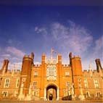

Badges and heraldry
The most obvious traces of Henry and his family can be seen in the symbols around the palace. At a time when few people could read, these coats of arms and badges (simple signs) were used to symbolise families.
See if you can find these badges around Hampton Court, and write down where you saw it:
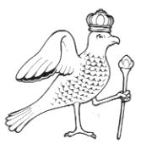
The Falcon -
Anne Boleyn’s badge
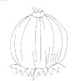
The pomegranate -
Catherine of Aragon’s badge
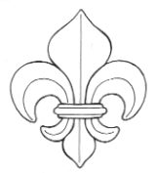
Fleur de lys -
Badge of France
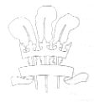
Three white feathers -
Prince Edward VI‘s badge

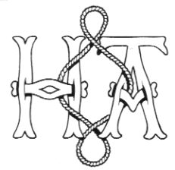
Initials of Henry VIII and Anne Boleyn
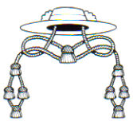
A cardinal’s hat -
Wolsey’s badge
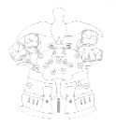
A phoenix and castle –
Jane Seymour’s badge
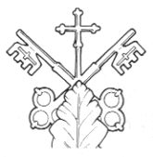
Crossed keys –
Wolsey’s badge as Archbishop of York

Base Court
- Look at Anne Boleyn’s Gateway. What do the letters A and H stand for?
_________________________________________________________________
- Why do you think that there is only a small amount of evidence for Anne Boleyn in the palace?
___________________________________________________________________________________________________________________________________________________________________________________________________
- How many lodgings, where guests would sleep, are there around Base Court? (estimate by counting the number of windows on the ground floor and first floor)
- Do you think the guests would be comfortable? (Give your reasons)
___________________________________________________________________________________________________________________________________________________________________________________________________
- What sort of facilities/things do you think they would have in their room?
__________________________________________________________________________________________________________________________________

Clock Court
Clock Court is named after the astronomical clock made in 1540 for Henry VIII. This was during the ‘Renaissance’ when learning about science, music, the stars and finding new countries was very fashionable.
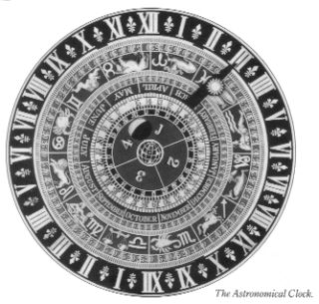
The long hand points to the hour of the day, the month, the day of the month and the zodiac. The small arrow on the middle dial points to the time, so that people knew when it was high tide at London Bridge. This was important because people travelled by river and needed to catch the tide.
- See if you can interpret the full date and zodiac displayed on the astronomical clock today.
________________________________________________________________
- Around Clock Court there are some stone carvings of Roman emperors that were once brightly painted. Try and sketch one here:

The Great Hall
- As you come up the stairs from Anne Boleyn’s gateway, there is a doorway on the left with two badges carved into it. Whose badges are they?
_________________________________________________________________
- Look at the stained glass windows in the Great Hall. What evidence is there of Henry VIII’s family?
__________________________________________________________________________________________________________________________________
- How would you describe this room and how does it make you feel?
___________________________________________________________________________________________________________________________________________________________________________________________________
- What do you think it’s for?
___________________________________________________________________________________________________________________________________________________________________________________________________
- Look at the tapestries on the walls. What did Henry want to show by these tapestries?
_________________________________________________________________
- What do you think the tapestry designs show?
_________________________________________________________________
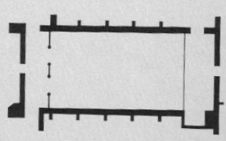
- On the diagram, mark the position of:
- The large window
- The minstrels’ gallery
- Where the open fire used to be
- The tapestries
- The Horn Room
- The Great Watching Chamber

- Look at the ceiling to see the small, carved and painted heads. Why do you think these are here?
_________________________________________________________________
- How many people could dine in here, and where would the most important people eat?
__________________________________________________________________________________________________________________________________
- How was the hall heated and lit?
__________________________________________________________________________________________________________________________________
- Was there any entertainment?
__________________________________________________________________________________________________________________________________

The Horn Room
- What animals are these horns from?
_________________________________________________________________
- How are they at Hampton Court?
______________________________________________________________________________________________________________________________________________

The Great Watching Chamber
- Is this more or less impressive than the Great Hall? Why?
___________________________________________________________________________________________________________________________________________________________________________________________________
- What did Yeomen of the Guard do?
__________________________________________________________________________________________________________________________________
- Can you find pictures of Tudor instruments? Do the people playing them seem rich or poor?
__________________________________________________________________________________________________________________________________
- In this room there are badges of one of Henry’s wives. Where are they, and which wife do they symbolise?
_________________________________________________________________

The Haunted Gallery
- Write the names of the five paintings in this gallery:
_____________________________________________________________________________________________________________________________________________________________________________________________________________________________________________________________________________________________________________________________________
- What is interesting about the painting The Family of Henry VIII?
___________________________________________________________________________________________________________________________________________________________________________________________________
- Which wife is said to haunt this corridor?
_________________________________________________________________
- Where was the meeting that is named The Field of the Cloth of Gold?
_________________________________________________________________

