Henry VIII

Henry VIII is one of the most famous English kings. He was eighteen when he became king after the death of his father Henry VII.

In some ways Henry was a hero – he was tall, handsome and good at many things, such as sport and music. But he was also spoilt and selfish. He always wanted his own way and was cruel to those who opposed him. He married six times. His wives were Catherine of Aragon, Anne Boleyn, Jane Seymour, Anne of Cleves, Catherine Howard and Catherine Parr.

Look at this picture of Henry VIII. See if you can list 10 words that describe his appearance. When you have done that, write a short paragraph describing him, using some of your words. Try to use similes in your description.

_________ ________ _________ _________ _________

_________ ________ _________ _________ _________

______________________________________________________

______________________________________________________

______________________________________________________
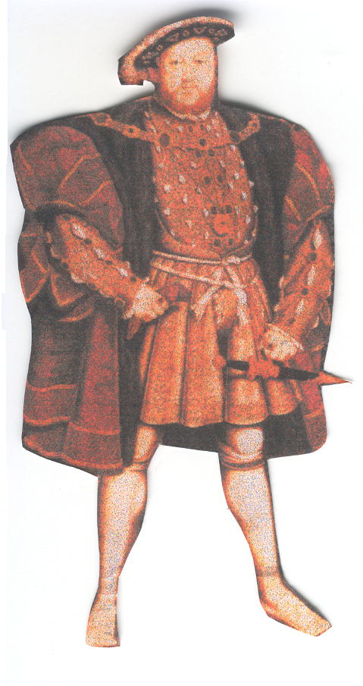

______________________________________

______________________________________

______________________________________

______________________________________

Henry VIII

Henry VIII is one of the most famous English _______. He was eighteen when he became king after the death of his _______ Henry VII.

In some ways Henry was a _______ – but he was also spoilt and _______ . He always wanted his own way and was cruel to those who opposed him. He married six times. His _______ were Catherine of Aragon, ______ Boleyn, ______ Seymour, Anne of Cleves, Catherine Howard and Catherine Parr.

father Anne hero kings Jane selfish wives

Look at this picture of Henry VIII. See if you can list 5 words that describe his appearance?

Henry VIII

Henry VIII is one of the most famous English kings. He was eighteen when he became king after the death of his father Henry VII.

In some ways Henry was a hero – but he was also spoilt and selfish. He always wanted his own way and was cruel to those who opposed him. He married six times. His wives were Catherine of Aragon, Anne Boleyn, Jane Seymour, Anne of Cleves, Catherine Howard and Catherine Parr.

Look at this picture of Henry VIII. See if you can list 5 words that describe his appearance. When you have done that, write a short paragraph describing him, using some of your words. Try to use similes in your description.

_________ ________ _________ _________ _________

______________________________________________________

______________________________________

______________________________________

______________________________________

______________________________________

