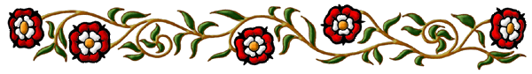

Henry VIII

Who was Henry VIII?
______________________________________________________________

When was he born?
_______________________________

When did he reign (came to power)?
_______________________________

Who were his parents?
Portrait of Henry VIII
_______________________________

How many times did he marry?
_________________________________________________________

Write the names of his wives in order.
1. _________________________ 2. _________________________
3. _________________________ 4. _________________________
5. _________________________ 6. _________________________

What does Henry look like?
__________________________________________________________________________________________________________________

What was Henry’s problem?
__________________________________________________________________________________________________________________

