Children in the  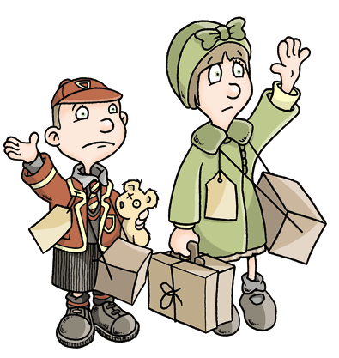  My Dictionary  _____________________ | A – E  Air raid _______________________________  Allies ________________________________  Billeting officer _________________________  Blackout ______________________________  Blitz ________________________________  Bomb ________________________________  Evacuation ____________________________  ____________________________________  ____________________________________  ____________________________________ | F – J  Gas mask ______________________________  _____________________________________  _____________________________________  _____________________________________  _____________________________________  _____________________________________  _____________________________________  _____________________________________  _____________________________________  _____________________________________
K – O  _____________________________________  _____________________________________  _____________________________________  _____________________________________  _____________________________________  _____________________________________  _____________________________________  _____________________________________  _____________________________________  _____________________________________ | P – T  Rationing ______________________________  Refugee ______________________________  Salvage _______________________________  _____________________________________  _____________________________________  _____________________________________  _____________________________________  _____________________________________  _____________________________________  _____________________________________ | U – Z  Victory _______________________________  Wireless ______________________________  _____________________________________  _____________________________________  _____________________________________  _____________________________________  _____________________________________  _____________________________________  _____________________________________  _____________________________________

