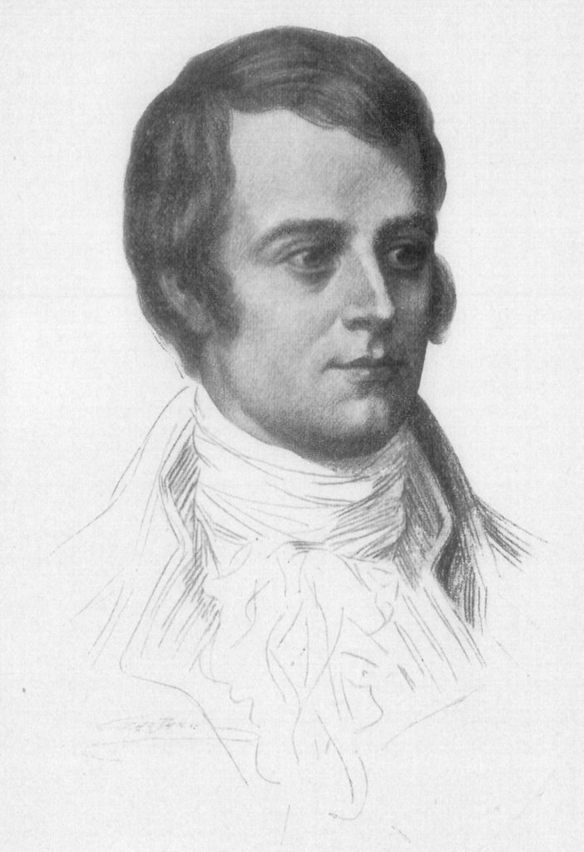
Robert Burns (1759-1796)

Robert Burns was a Scottish poet. Burns is our National Poet and is famous throughout the world for his poems and songs. Burns was born into a poor farming family, but was lucky to receive a good education. He began to write songs and poems and became very famous before he died.

Every year people celebrate his birthday on January 25th by holding a Burns Supper. At Burns Suppers people eat traditional Scottish food. Most people enjoy haggis, neeps and tatties. They may also enjoy a dram of whiskey. After the meal people recite Burns' poems, sing his songs and talk about his life. Burns Suppers will take place all over Scotland. Burns is so well known that people also celebrate his birthday all over the world.

- Why is Robert Burns famous?

- How do we celebrate his life?

- Can you name a poem or a song that he wrote?

