Samuel Pepys – Diarist 1633-1703

l---------l---------l---------l---------l---------l---------l
1500 1600 1700 1800 1900 2000 2100

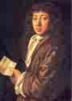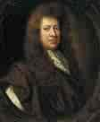

What questions would you ask Samuel Pepys about the Great Fire of London?

1

2

3

4

5

