The Golden Hinde 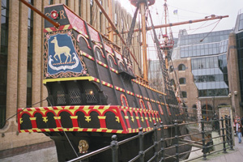

Today we boarded a ship
For our termly topical trip.
We clambered up the gangplank
Tightly gripping the rope from the bank.
We clattered onto the deck
Squashing onto this lovely old wreck.

A Tudor sailor was our guide
He showed us the ship with great pride.
On the main deck we rang the bell
To sailors the time it did tell.
The end of each watch it did mark
Or sighting of land it did hark.

We peeked into the Captain’s cabin
A small room with furniture sagging
On the main deck squeezed into the bow
Away from the squalor and row
Of the sailors bent double below
‘Cause the ceiling was terribly low.

Those sailors were constantly wet
As water poured through in a jet
No windows or cosy portholes
No fires with hot burning coals
But massive great cannons and shot
And smells of decaying and rot.

On this deck the sailors would sleep
And through their clothes urine would seep
As bathrooms just could not be found
Within this confusing compound
Where animals lived with the crew
The noise was most deafening too.

We crouched down to move round this floor
Went down the stairs with a great roar
Beneath was the store or the hold
Where sailors were punished of old
By nailing their hand to a pole
Discomfort and pain was the goal.

The life of a sailor was tough
The seas and their treatment quite rough
Their life ‘board the ship was so bleak
I couldn’t have lasted a week
Without the least bit of pleasure
Though I wish I had all of their treasure.

Rona Dixon February 2006

