Queen Victoria

Victoria was born on 24th May _________. ( 1819/ 1066 /1939) She had a ____________ (great/ lonely/hard) childhood. This was because she had no brothers or sisters to play with and she hardly went out. She was not even a year old when her father _________ (Eric/Edward/Edmund) Duke of Kent, died. Her uncle, King William IV had no children so Victoria would inherit the throne when he died.

Victoria was twelve years old when she was told she might become the next _________. (princess/queen/duchess) When she was ______ (8/118/18) her uncle died and she became the Queen of _______________. (Britain/Africa/ America)This was in _________. (1800/1900/1837)

When Victoria was 20 she married her German cousin called Prince _________ (Andrew/Arthur/Albert) who was the same age as her. They loved each other dearly and had _____ (7/9/19) children, four boys and five girls. When Albert died Queen Victoria was very _____________. (happy/sad/grumpy) She refused to go out in public for ____ (2/5/10) years.

On June 22nd 1897 people were given a special bank holiday to celebrate the Queen’s ___________ (Silver /Golden/Diamond) Jubilee. People from all over Britain marched through London to celebrate her ___ (25/50/60) years as Queen.

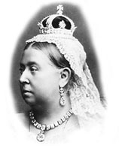
Queen Victoria died in ________. (1901/1109/9100) She was _____ (22/52/82) years old. She was buried beside her husband __________ (Andrew/Arthur/Albert) at Windsor Castle.

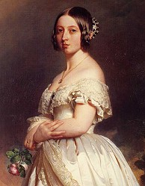
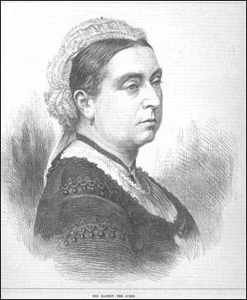

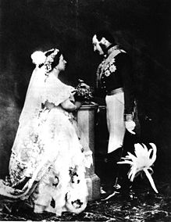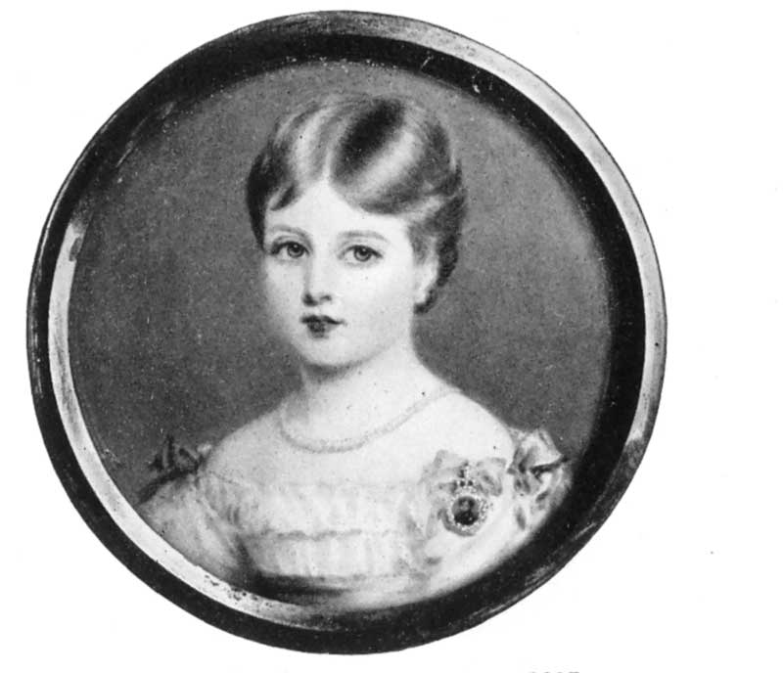

Princess Victoria in 1827.

Queen Victoria in 1897.

Princess Victoria in 1837.

Queen Victoria in 1840.

In this portrait she is 78 years old.

In this portrait she is 21 years old.

In this portrait she is 18 years old

In this portrait she is 8 years old

Victoria becomes Queen.

She lives in Kensington palace and is escorted everywhere.

She is wearing black because she is now a widow. Her husband Albert died in 1861.

She is marrying her German cousin Albert.

