Resources on WW2 and memory interviews.

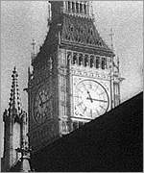
Tuesday, 21 September, 1999, 08:39 GMT 09:39 UK
BBC News Online has delved into the BBC Archives for eyewitness accounts of the day when war broke out.
When the clock struck 11
Chamberlain's speech
Veterans and civilians reflect on how they felt after hearing the prime minister's broadcast.
Britain was at war from 11 o'clock - Chamberlain made his radio broadcast at 1115.

http://news.bbc.co.uk/olmedia/430000/video/_430152_heard_about2_vi.ram

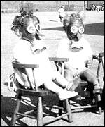
In the months leading up to the outbreak of the war many thousands of children were evacuated to the countryside.
Departure from Waterloo
BBC Reporter S J de Lotbinière was at Waterloo station to see off hundreds of schoolchildren on September 1, 1939.

http://news.bbc.co.uk/1/hi/special_report/1999/08/99/world_war_ii/430152.stm

"How do you spell 'yokels'?"
Charles Gardiner, Clerk of Evesham Rural District Council, remembers looking after evacuees.

http://news.bbc.co.uk/olmedia/430000/audio/_430152_charles_gardiner.ram

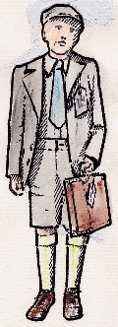
Wartime Evacuation of children. Making labels: Materials required:
- Card luggage label
- Short piece of string (preferably sisal)
- Pen or pencil
Provide each child with a luggage label on which they write their name and age in capital letters. Thread string through the label.
Pin label on to the child (or thread through buttonhole).

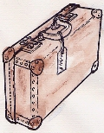
Topic: Wartime Evacuation of Children
“Contents of the Suitcase” - Worksheet suggestions

1. Make a list of things that you would think would be in the suitcases of the evacuees – either a boy or a girl.

2. What would you pack in a suitcase if you ere told that you were to go away from home for a very long time?

3. In what ways would your suitcase contents be different from those of a boy or girl evacuee?

4. Tell us about your favourite toy or pastime and why you would miss it if it were to be taken away.

http://www.bbc.co.uk/history/ww2children/index.shtml

Animation film on the evacuees of London……
http://www.bbc.co.uk/history/worldwars/wwtwo/launch_ani_wwtwo_movies_evacuees.shtml

The sounds of the war air raid siren and guns …….
http://www.eyewitnesstohistory.com/pfblitz.htm
This was the beginning of the Blitz - a period of intense bombing of London and other cities that continued until the following May. For the next consecutive 57 days, London was bombed either during the day or night. Fires consumed many portions of the city. Residents sought shelter wherever they could find it - many fleeing to the Underground stations that sheltered as many as 177,000 people during the night. In the worst single incident, 450 were killed when a bomb destroyed a school being used as an air raid shelter. Londoners and the world were introduced to a new weapon of terror and destruction in the arsenal of twentieth century warfare. The Blitz ended on May 11, 1941 when Hitler called off the raids in order to move his bombers east in preparation for Germany's invasion of Russia.

Fantastic audio clips of the war ….
Sirens, gas mask instructions, VE Day celebrations

http://www.bbc.co.uk/schoolradio/history/worldwar2audioclipslibrary_clip36.shtml

