World War Two- Art Task
Task Outline- Make a poster that will help win the war.
You may use a computer to write the text for your poster.
The pictures on your poster should be drawn by hand.
Your finished poster should be A4 sized. Coloured paper can be used.

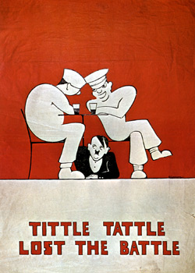
Poster Themes-
Your poster should focus on one of the following themes:
(1) To encourage women to work
(2) To save waste and recycle
(3) To keep the nation safe — e.g. be alert for spies

Idea Bank-
men strength muscle
women work feminine strong
government conservation ration
spies enemy talk careless safety

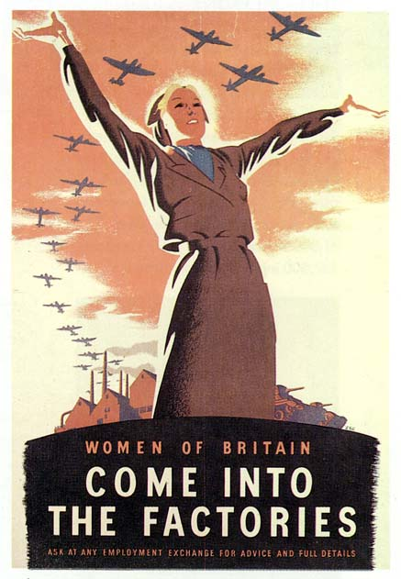
Persuading the Public
The government posters used a variety of techniques to persuade the public to believe the messages.
Try to use these techniques in your own poster.

Alliteration—repeating letters eg peter picked a pepper
Colour suggestions eg red = danger; black = death;
Pun—word with two meanings eg role / roll
Humour- a joke is memorable.
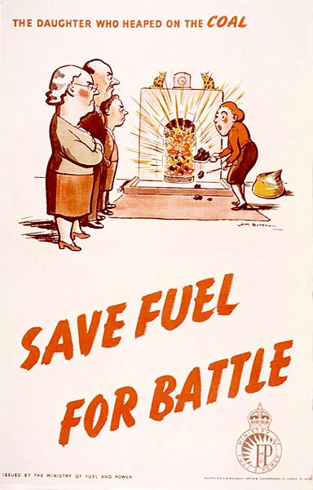
Planning & Design-
1) Decide on the theme for your poster.
- Write a slogan to explain your message.
- Ask a friend to comment on your slogan
- is it persuasive?
- does it include alliteration/ a joke/ a pun?
4) On scrap paper sketch your picture and layout of text.
5) Type or write your text- choose a font carefully.
6) Complete your poster by adding the text to the illustration.

- For some inspiration, take a look at St Andrews University’s website- click on ‘Posters’. There are WWII posters on lots of themes on this website.
http://www.st-andrews.ac.uk/~pv/pv/courses/posters/posters.html

