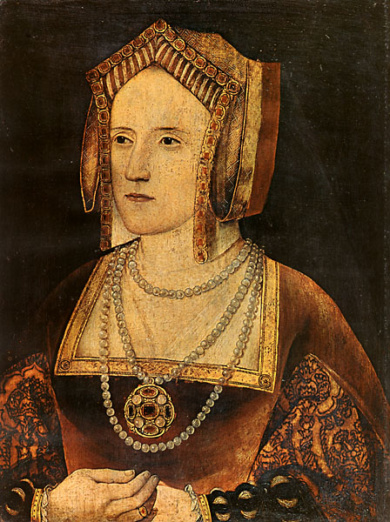

Katherine Parr

Birth: 1512
Birthplace: England
Death: 7th September 1548
Best Known As: Sixth and final wife of Henry VIII (Widowed)

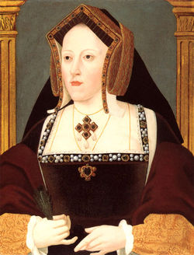

Catherine of Aragon

Birth: 16th December 1485
Birthplace: Alcala de Henares, Spain
Death: 7th January 1536 (natural causes)
Best Known As: First wife of Henry VIII and the mother of Mary I (Divorced 1533)

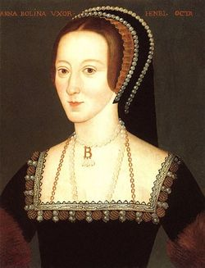

Anne Boleyn

Birth: 1502
Birthplace: England
Death: 19th May 1536
Best Known As: Second wife of Henry VIII and the mother of Elizabeth I (Beheaded)

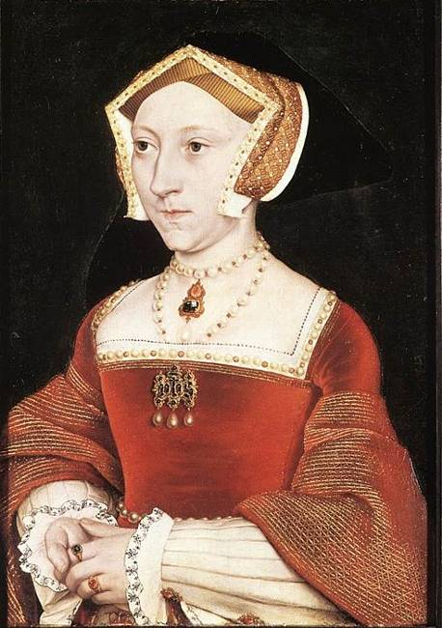

Jane Seymour

Birth: 1505
Birthplace: England
Death: 24th October 1537
Best Known As: Third wife of Henry VIII and the mother of Edward VI (Died)

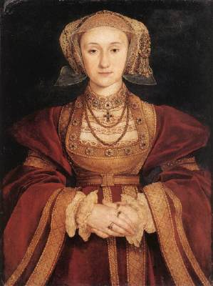

Anne of Cleves

Birth: 22nd September 1515
Birthplace: Germany
Death: 17th July 1557
Best Known As: Fourth wife of Henry VIII (Divorced 1540)

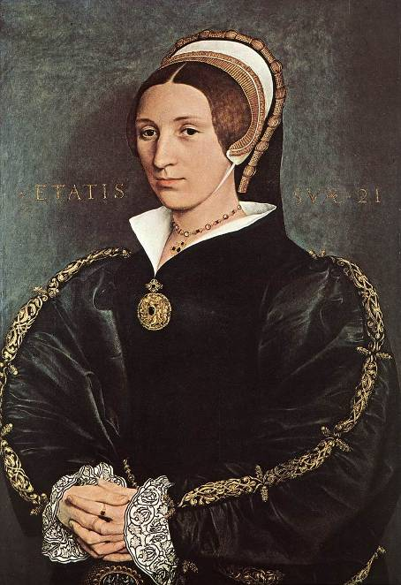

Catherine Howard

Birth: 1520
Birthplace: England
Death: 13th February 1542
Best Known As: Fifth wife of Henry VIII (Beheaded)

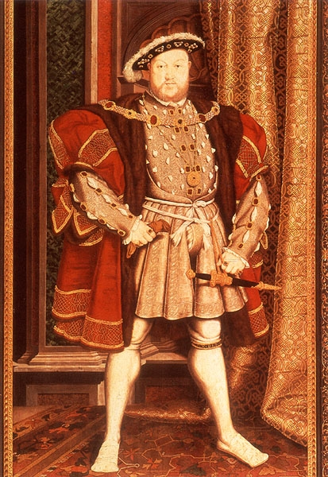

Henry VIII

Birth: 24th June 1491
Birthplace: England
Death: 28th January 1547
Best Known As: Married six times and he was crowned aged 18 on the 24th June 1509

