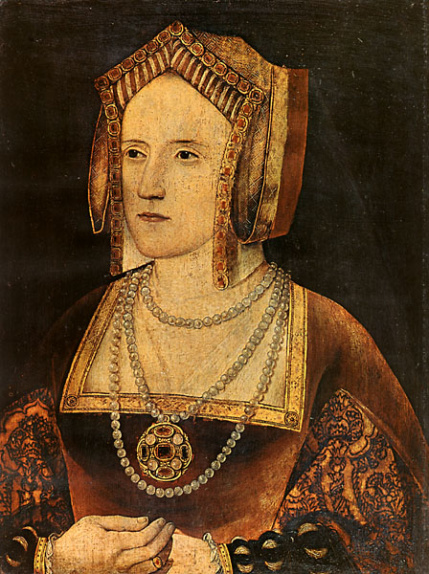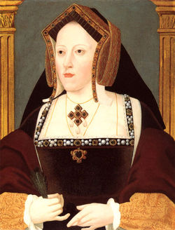

Catherine of Aragon
Katherine Parr

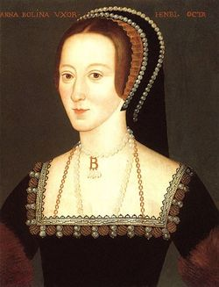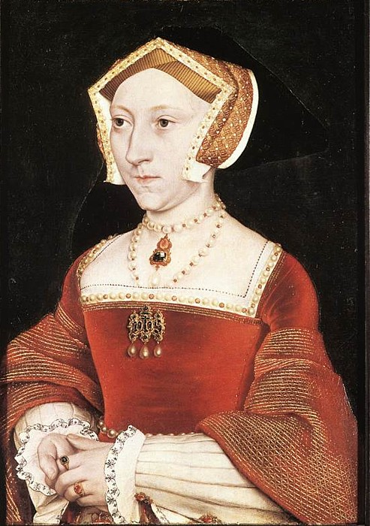

Anne Boleyn
Jane Seymour

Catherine of Aragon
Katherine Parr

Anne Boleyn
Jane Seymour

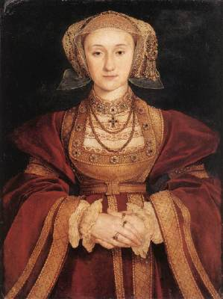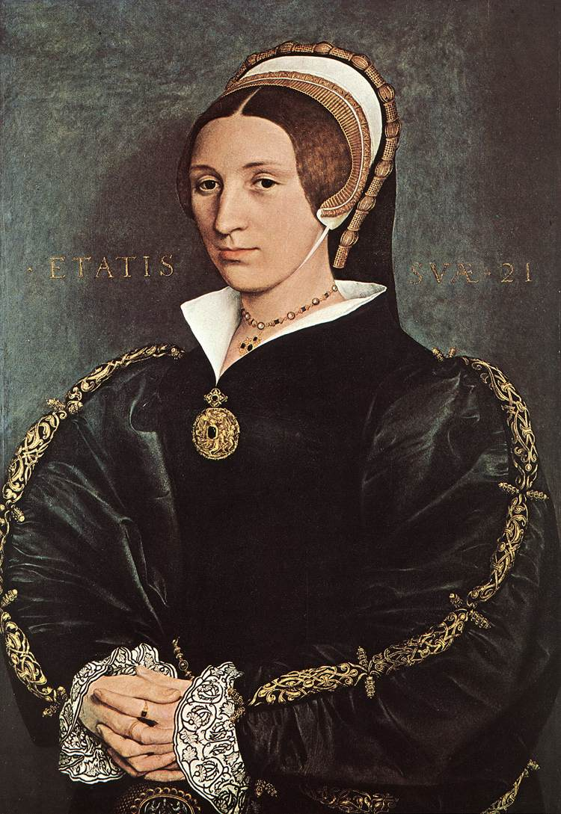
Catherine Howard
Anne of Cleves

Catherine Howard
Anne of Cleves

