The Battle of Britain

After the evacuation of *****, Churchill made a famous speech. He said, "We shall fight them on the *******. We shall fight on the landing grounds, in the fields, in the streets and in the hills. We shall never surrender."
Churchill knew now that after the fall of France the Battle of ******* would begin. Hitler wanted to ***** Great Britain. He knew that before his troops invaded he must try and destroy the Royal Air Force, the ***. If the RAF remained strong in the skies, they would be able to attack the German *********.
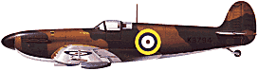
Hitler sent his planes to destroy the British ********. However radar helped to detect the German ****** and they were destroyed before they got too close. The Germans knew all about the radar ******** but did not think they were important, and did not even try to ******* them.
Thousands and thousands of planes filled the air. The British flew ********* and hurricanes, while the German flew Messerschmitts. Throughout August and ********** of that year dogfights were continuous. Hitler soon realised he could not win, and he put off his plans for ********.
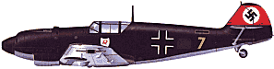

Dunkirk September RAF beaches Britain invasion soldiers destroy invade airbases planes stations spitfires

