An Evacuee’s Suitcase
You are about to be evacuated. You are packing your suitcase with your mum. What 12 items will you take with you? Remember that you will have to take clothes so there will not be a lot of room for “extras.”
- Draw the items in the suitcase.
- List the items you are taking.
- Write a sentence or sentences explaining why you are taking the item.
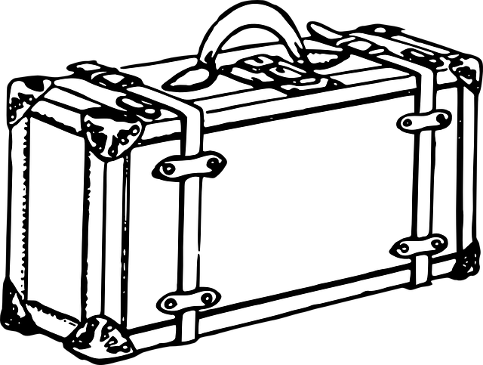

I have packed these items:
1 | 2 | 3 | 4
5 | 6 | 7 | 8
9 | 10 | 11 | 12

Write a sentence or sentences explaining what you are taking and why?
1.

2.

3.

4.

5.

6.

7.

8.

9.

10.

11.

12.

