World War 2 Timeline (Reds)
Put these events in the correct time order

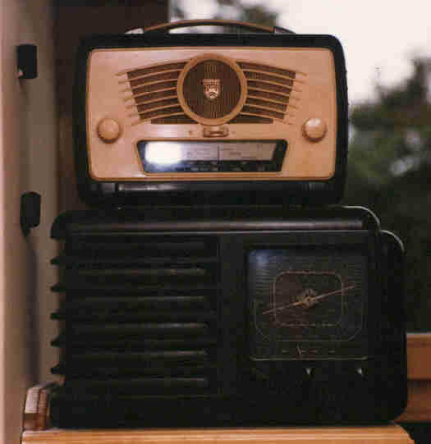
In 1939, Hitler invaded Poland. Britain listened to the radio. Chamberlain
said that we were at war with Germany.

Hitler became Chancellor of Germany in 1933.
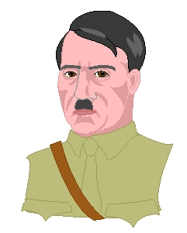
He started to take back land that
they’d lost in the World War 1.

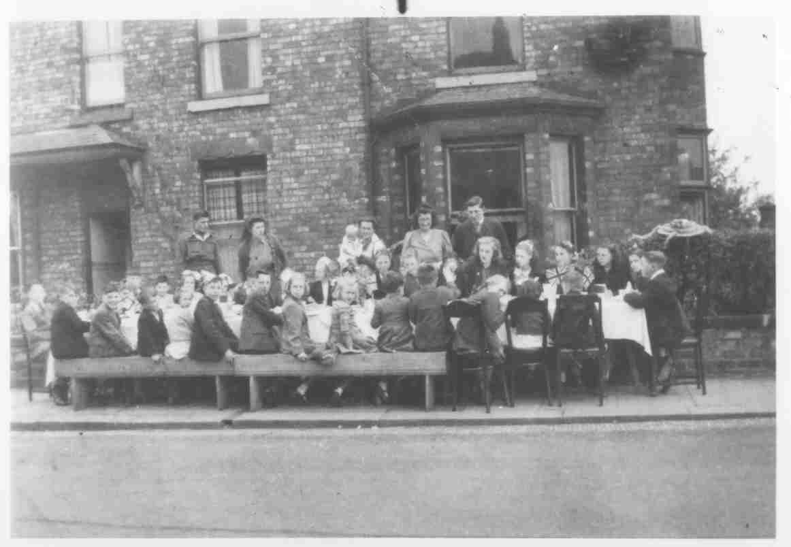
In 1945 the war in Europe was
over!
In Britain people had street
parties

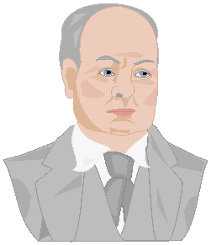
In 1940 the Blitz began
and Churchill became Prime Minister.

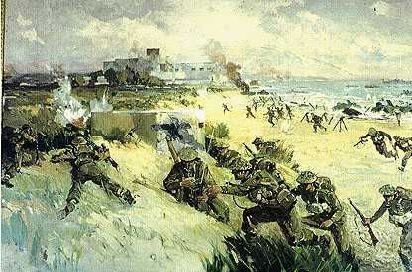
On D-Day in 1944 the Allies landed on
the beaches of France.

Now can you add any extra information you know.

World War 2 Timeline
Put these events in the correct time order
In 1939, when Hitler invaded Poland, Britain listened to the radio as Chamberlain
announced that we were at war with Germany.

Hitler became Chancellor of Germany in 1933.
He started to take back land that they’d
lost in the World War 1.

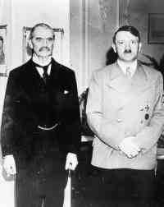
Neville Chamberlain, our Prime Minister, met with Hitler to try and avoid war.
He also made an agreement with Poland
to support each other in the event of war.

In 1945 peace was declared. The war in Europe was over! In Britain people had
street parties to celebrate

In 1940 the Blitz began. The Blitz began
and Churchill became Prime Minister.

On D-Day in 1944 the Allies landed on
the beaches of German occupied France.

Now can you add any extra information you know.

World War 2 Timeline
Put these events in the correct time order
In 1939, when Hitler invaded Poland, Britain listened to the radio as Chamberlain
announced that we were at war with Germany.

Hitler became Chancellor of Germany in 1933.
He started to take back land that they’d
lost in the World War 1.

Neville Chamberlain, our Prime Minister, met with Hitler to try and avoid war.
He also made an agreement with Poland
to support each other in the event of war.

In 1945 peace was declared. The war in Europe was over! In Britain people had
street parties to celebrate

In 1940 the Blitz began. The Blitz began
and Churchill became Prime Minister.

On D-Day in 1944 the Allies landed on
the beaches of German occupied France.

Now can you add any extra information you know.

