Fact Sheet – Year 6 (Login in to Robolab Online first)
www.robolabonline.com
Focus: To examine the various icons used in ROBOLAB and learning their functions (Pilot 1 and 2 icons).
Complete the table and print. Please include your name and class!
 | Icon | Name (Choose) | Description of function (Hover over web icon)
1 | 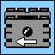
2 | 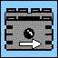
3 | 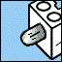
4 | 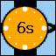
5 | 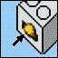
6 | 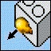
7
Name: |  |  |  | Class:
When you have completed the exercise please ‘Save As’ – ‘Robolab’ and print a copy of your work having included your name and class. Now you can move onto ‘Pilot’s 1 and 2’

