To identify properties of shapes
3a / 4c / 4b | 3b | 2a / 3c
I know when a line is horizontal or vertical. (3a)  I can say whether a triangle is right-angled, equilateral, isosceles or scalene and explain how I know. (4c/4b)  I can explain whether a shape has line symmetry and whether it has any parallel or perpendicular sides. (4c/4b) | I can reflect a shape when the mirror line is one of its sides. (3b)  I can use what I know about polygons to group them into regular and irregular polygons. (3b)  I can use what I know about triangles to group them into equilateral triangles, isosceles triangles and other triangles. (3b) | I can draw a line of symmetry on a shape. (2a)  I can sort shapes into sets, saying what is the same about each of the shapes. (3c)

- Sort the following 2D shapes according to your own criterion:

A B C D E

These shapes have................. | These shapes do not have .......

- Which of these shapes above are quadrilaterals?
- Draw two different quadrilateral shapes and label them ‘A’ and ‘B’.
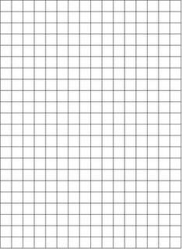
- Look at the two shapes you have drawn and list different properties of each shape. Try to think of different properties other than the number of sides.
Shape A  is a ..................................................... | Shape B  is a .....................................................

- Look at the following triangles. What can you say about each one? It may help to measure them with your ruler.
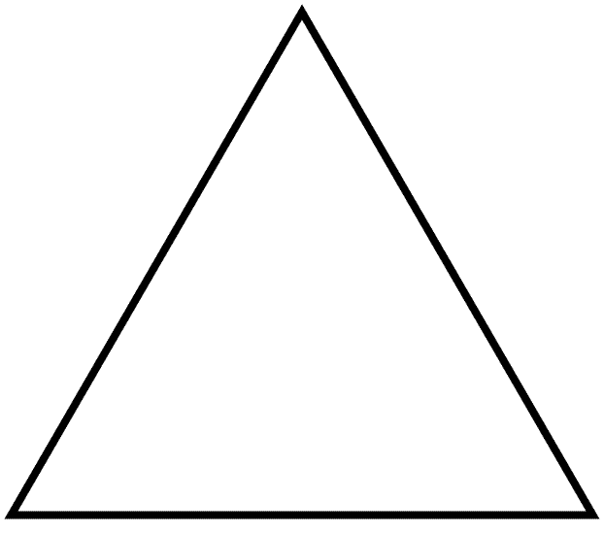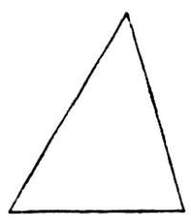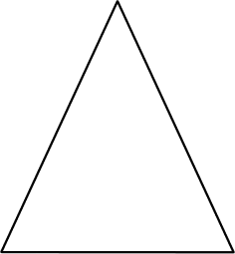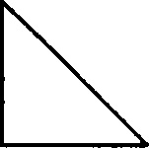

- Draw a shape on the squared paper on one side of the mirror line (use your ruler). Can you reflect it in the mirror line?

