LO: To solve fraction word problems

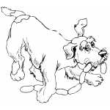
- A chef prepares 640 cocktail sausages for a party. Unfortunately an escaped dog snatches ³/₈ of them and runs off! How many sausages were left?
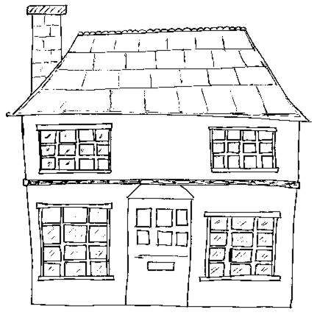
- The Air Raid Warden has 755 homes to visit. Unfortunately he missed ²/₅ of them out due to an emergency. How many homes did he manage to visit?
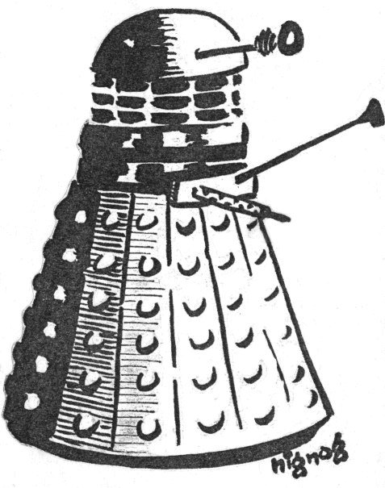
- Dr Who cards are on special offer. They normally cost £3.60 per packet but have been reduced by a sixth. How much will a packet cost now? How much have you saved?
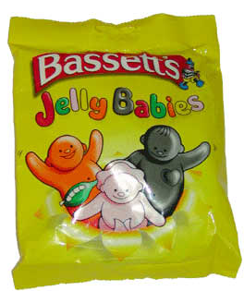
- If ¼ of a large packet of Jelly Babies has 57 sweets, how many are there in a whole packet? If Bob ate ½ the packet, how many Jelly Babies would he get?
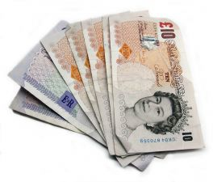
- Mrs Green has saved up £1600. She wants to use ³/₁₀ of it for her birthday party and ⁵/₁₀ of it for holiday. How much money will see need to take out of her savings? How much money will she have left for her two grandchildren?
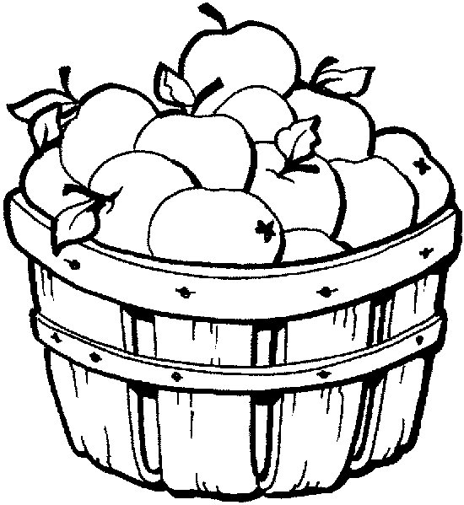
- The apple farmer picks 720 apples on Monday morning. The next morning he only manages to pick ²/₈ of that amount. How many apples is that altogether? If he takes ¹/₃ of the apples to market on Wednesday, how many will he be left with?


- A T.V costs £1750, a DVD player costs £250 and a Nintendo Wii costs £180. In the end of season sale, the T.V is reduced by ²/₅, the DVD player is half price and the Nintendo Wii has ¹/₃ off. How much does each item cost in the sale and which item do
you save the most money on?
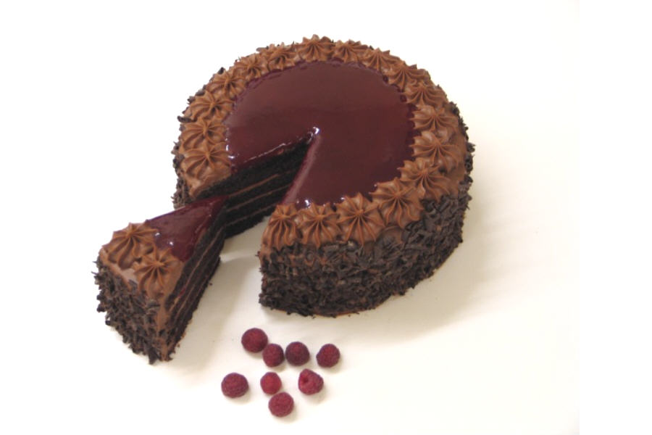
- A very large chocolate cake weighs 4.8Kg and is cut into twelfths. Mary eats ²/₁₂ of the cake and Sally eats ¹/₈ of the cake. Who eats more and how do you know?
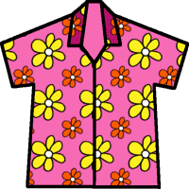
- Fred had £270. He spends half of his money on clothes and ²/₅ on DVDs. How much money did he spend on each thing? Was there any change?
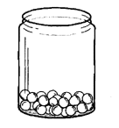
- There are 5600 marbles in a jar. ¼ of the marbles are red and ¹/₈ of the marbles are green and the remainder is blue. How many marbles are there of each colour? If two children were to divide each colour equally between them, how many red, green and blue marbles would they get?

If you have finished make up some of your own fraction word problems and give them to a partner to solve. Make sure you know the answers though!!
LO: To solve fraction word problems
- A chef prepares 360 cocktail sausages for a party. Unfortunately an escaped dog snatches ²/₆ of them and runs off! How many were left?
- The Air Raid Warden has 150 homes to visit. Unfortunately he missed ²/₅ of them out due to an emergency. How many homes did he manage to visit?

- Dr Who cards are on special offer. They normally cost £2.10 per packet but have been reduced by a third. How much will a packet cost now? How much have you saved?
- If ¼ of a packet of Jelly Babies is 13 sweets, how many are there in a whole packet? If Bob ate ½ the packet, how many Jelly Babies would he get?

- Mrs Green has saved up £300. She wants to use ²/₁₀ of it for her birthday party and ⁵/₁₀ of it for holiday. How much money will see need to take out of her savings?
- The apple farmer picks 240 apples on Monday morning. The next morning he only manages to pick ³/₆ of that amount. How many apples is that altogether?

- A T.V costs £750 and a DVD player costs £140. In the end of season sale, the T.V is reduced by ¹/₅ and the DVD player is half price. How much does each item cost in the sale?
- A large chocolate cake weighs 800g and is cut into quarters. How much does ¾ of the chocolate cake weigh? Mary decides that one quarter will be too much to eat and cuts the cake into eighths. How many grams will be in ¹/₈?

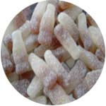
- Fred had £3. He spent half of his money on jelly beans and one third on fizzy cola bottles. How much money did he spend on each type of sweet? How much change did he get?
- ²/₃ of the marbles in a jar are red, and ¼ are green. If there are 600 marbles in the jar, how many are red and how many are green?

If you have finished make up some of your own fraction word problems and give them to a partner to solve. Make sure you know the answers though!!

