Fractions for Beginners

Write the fraction for the pictures below

1.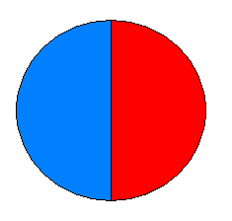what fraction is red? …………………

2.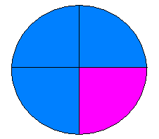what fraction is purple? …………………

what fraction is blue? …………………

3. 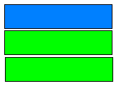 what fraction is green? ………………………

what fraction is blue? ………………………

4. 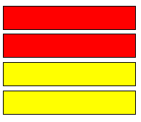 what fraction is yellow? ……………………

5. 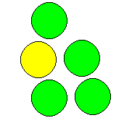 what fraction is yellow? ……………………

what fraction is green? ……………………
Questions:

1. Sam has four pieces of chocolate he gives one piece to his

Friend. What fraction does Sam have left? ………………………

What fraction does his friend have? …………………………

2. Jasmine has two oranges she shares one with Hannah, what

fraction does Jasmine have left? ……………………

3. David has 30 pence he gives 10 pence to Jonathon, what

fraction of the money does Jonathon have? ……………… What

fraction does David keep? ……………………
4. Sally bought five chocolate bars, she kept one for herself

gave two to Mohamed and two her brother. What fraction did

Sally keep for herself? …………………… What fraction did she give

to Mohamed? ……………………

Task: Use your ruler to divide the shapes into the fractions.

1. 2. 3.
Half Quarters Thirds

4. divide the square into quarters and colour three quarters red.

5. divide the square into thirds and colour two thirds green

