Ordering Decimals

Order the food from cheapest to most expensive. Write your answers as decimals.
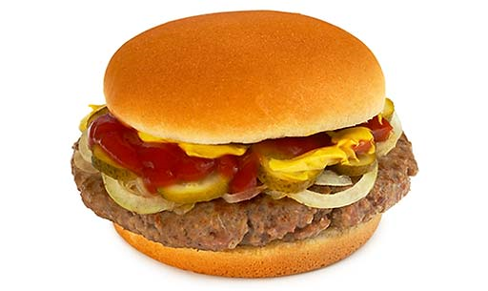
EXAMPLE:

£0.51 £0.22 £1.03

ANSWER: 0.22, 0.51, 1.03
----------------------------------------------------------------------------------

1.

£0.72 £0.44 £0.65

----------------------------------------------------------------------------------

2.

£0.41
£0.40
£0.25

3.

£0.91 £0.36 £0.95

4.

£1.42 £1.33 £1.19

5.

£3.21 £3.04 £3.14

6.

£5.15 £5.41 £5.05

