Name___________________________ Date ____________________
LO – To use money notation
Write how much money there is in each question

1) _______________
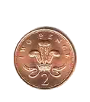

2) _______________
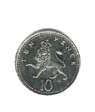

3) __________________


4) _______________


5) _______________

6) ______________


7) ________________


8) ______________

9) _____________


10) _____________

Select some coins for yourself and add up how much you have

